

**Workplace Communication Workshop**

The greatest problem in communication is the illusion that it has been accomplished. – George Bernard Shaw

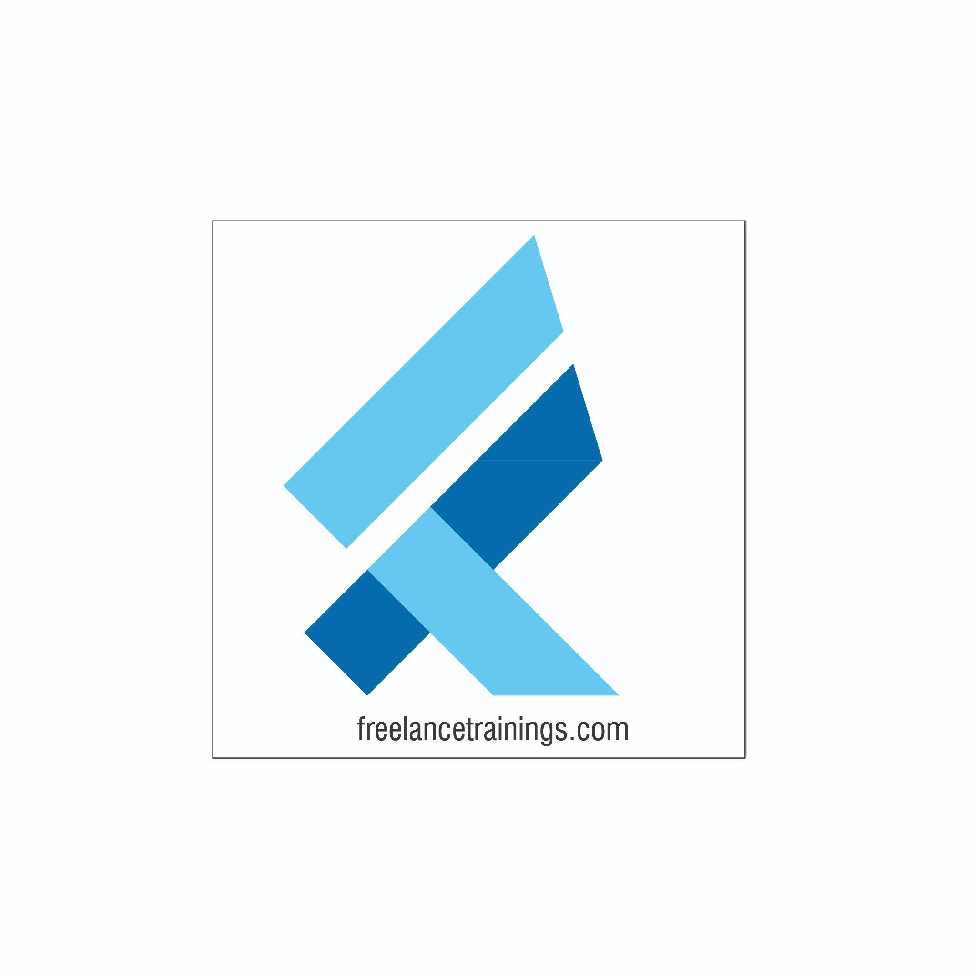

Workplace Communication Workshop

Duration: 2 Days

No of Participants: 25-30 Pax

Timing: 9:30 A.M- 5:30 P.M

Target Audience

* Individual Contributors
* Supervisors
* Early Team Managers
* Employees of any department

Workshop Objectives

* Understanding workplace communication
* Myths of workplace communication
* Communication Process
* Cornerstones of effective communication(5W & 1 H)
* LADR Model- Listening, Asking Question, Reconfirm
* 4 C's of effective communication
* Mehrabian Model-Verbal, Vocal & Visual
* Non-verbal communication & Its Components
* Assertive, Aggressive & Empathetic communication
* Communication Barriers

Workshop Outline

|  |  |  |
| --- | --- | --- |
| **Day 1** | | |
| **Sr. No.** | **Time** | **Topic** |
| 1 | 9:30-10:15 AM | **What’s In It for Me** • Workshop Intro & Agenda • Ground Rules • Icebreaker • Facilitator Intro • Participant Intro & Expectations |
| 2 | 10:15- 10:30 AM | **Pre Training Assessment** |
| 3 | 10:30- 11:00 AM | **Understanding Workplace Communication •** Understanding workplace communication? • Role of Communication- Individual • Role of Communication-Organisation • Benefits of workplace communication |
| 4 | 11:00 -11:15 AM | **First Tea Break** |
| 5 | 11:15 -12:30 PM | **Communication Process •** Understanding Communication process • Steps involved in the process • Role of each party • Myths about workplace communication |
| 6 | 12:30 -1:15 PM | **Cornerstone of Effective communication •** Communicate Impactfully-5W’s & 1 H • Why & What to communicate • Who, Where, When to communicate • How to draft a communication |
| 7 | 1:15 - 2:00 PM | **Lunch Break** |
| 8 | 2:00 - 2:15 PM | **Energiser** |
| 9 | 2:15- 3:00 PM | **4 C’s for Effective Communication •** Clear  • Concise • Concrete-Specific • Customised |
| 10 | 3:00-4:00 PM | **Making Communication Fool proof •** Applying LADR Model • Listening Actively • Asking Questions • Doubts Clarify • Reconfirm |
| 11 | 4:00 - 4:15 AM | **Second Tea Break** |
| 12 | 4:15- 4:45 PM | **Forms of Communication •** Mehrabian Model • Verbal • Visual • Non Verbal-Communication |
| 13 | 4:45- 5:00 PM | **Recap of Day 1** |
| 14 | 5:00 - 5:30 PM | **Closing** • Q& A • Closing Video  • Homework for day 2 (Optional) |
| **Day 2** | | |
| **Sr. No.** | **Time** | **Topic** |
| 1 | 9:30-10:00 AM | **What’s In It for Me** • Recap of Day 1-Activity • Agenda |
| 2 | 10:00- 11:15 AM | **Verbal Communication  •** Importance of Verbal Communication • Verbal Communication Forms • Modes of Verbal Communication (Vocal, Visual, Written) |
| 3 | 11:15 -11:30 AM | **First Tea Break** |
| 4 | 11:30 - 12:15 PM | **Vocal Communication  •** Volume • Pace • Pause • Intonation • Pronunciation |
| 5 | 12:15 - 1:00 PM | **Visual & Written Communication  •** Visual Communication & Types • Written communication Types • Transactional • Informational • Instructional • Tips for Written communication |
| 6 | 1:00 - 1:45 PM | **Lunch Break** |
| 7 | 1:45 - 2:00 PM | **Energiser** |
| 8 | 2:00 - 2:45 PM | **Non Verbal Communication  •** Components of Non Verbal Communication • Importance of Nonverbal • Body Language • Gestures & Posture • Eye Contact • Facial Expressions |
| 9 | 2:45 - 3:30 PM | **Types of Communication** • Aggressive • Passive • Assertive • Empathetic |
| 10 | 3:30 - 4:15 PM | **Barriers in Communication** • Understanding Communication Barriers • Linguistic barriers • Psychological Barriers • Emotional Barriers • Physical Barriers • Cultural Barriers • Organisational Structure Barriers • Tips to overcome the barriers |
| 11 | 4:15- 4:30 PM | **Second Tea Break** |
| 12 | 4:30 - 4:45 PM | **Post Training Assessment** |
| 13 | 4:45 - 5:00 PM | **Recap Day 1 & 2** |
| 14 | 5:00 -5:30 PM | **Closing** • Feedback forms • Q& A (If any) • Closing Video (If any) • Group Photo |

*This Workshop outline is based on the industry best practices and will be customised after discussion with the client.*