

**Telesales Workshop**

“If you want something you have never had, you must be willing to do something you have never done.” — Thomas Jefferson

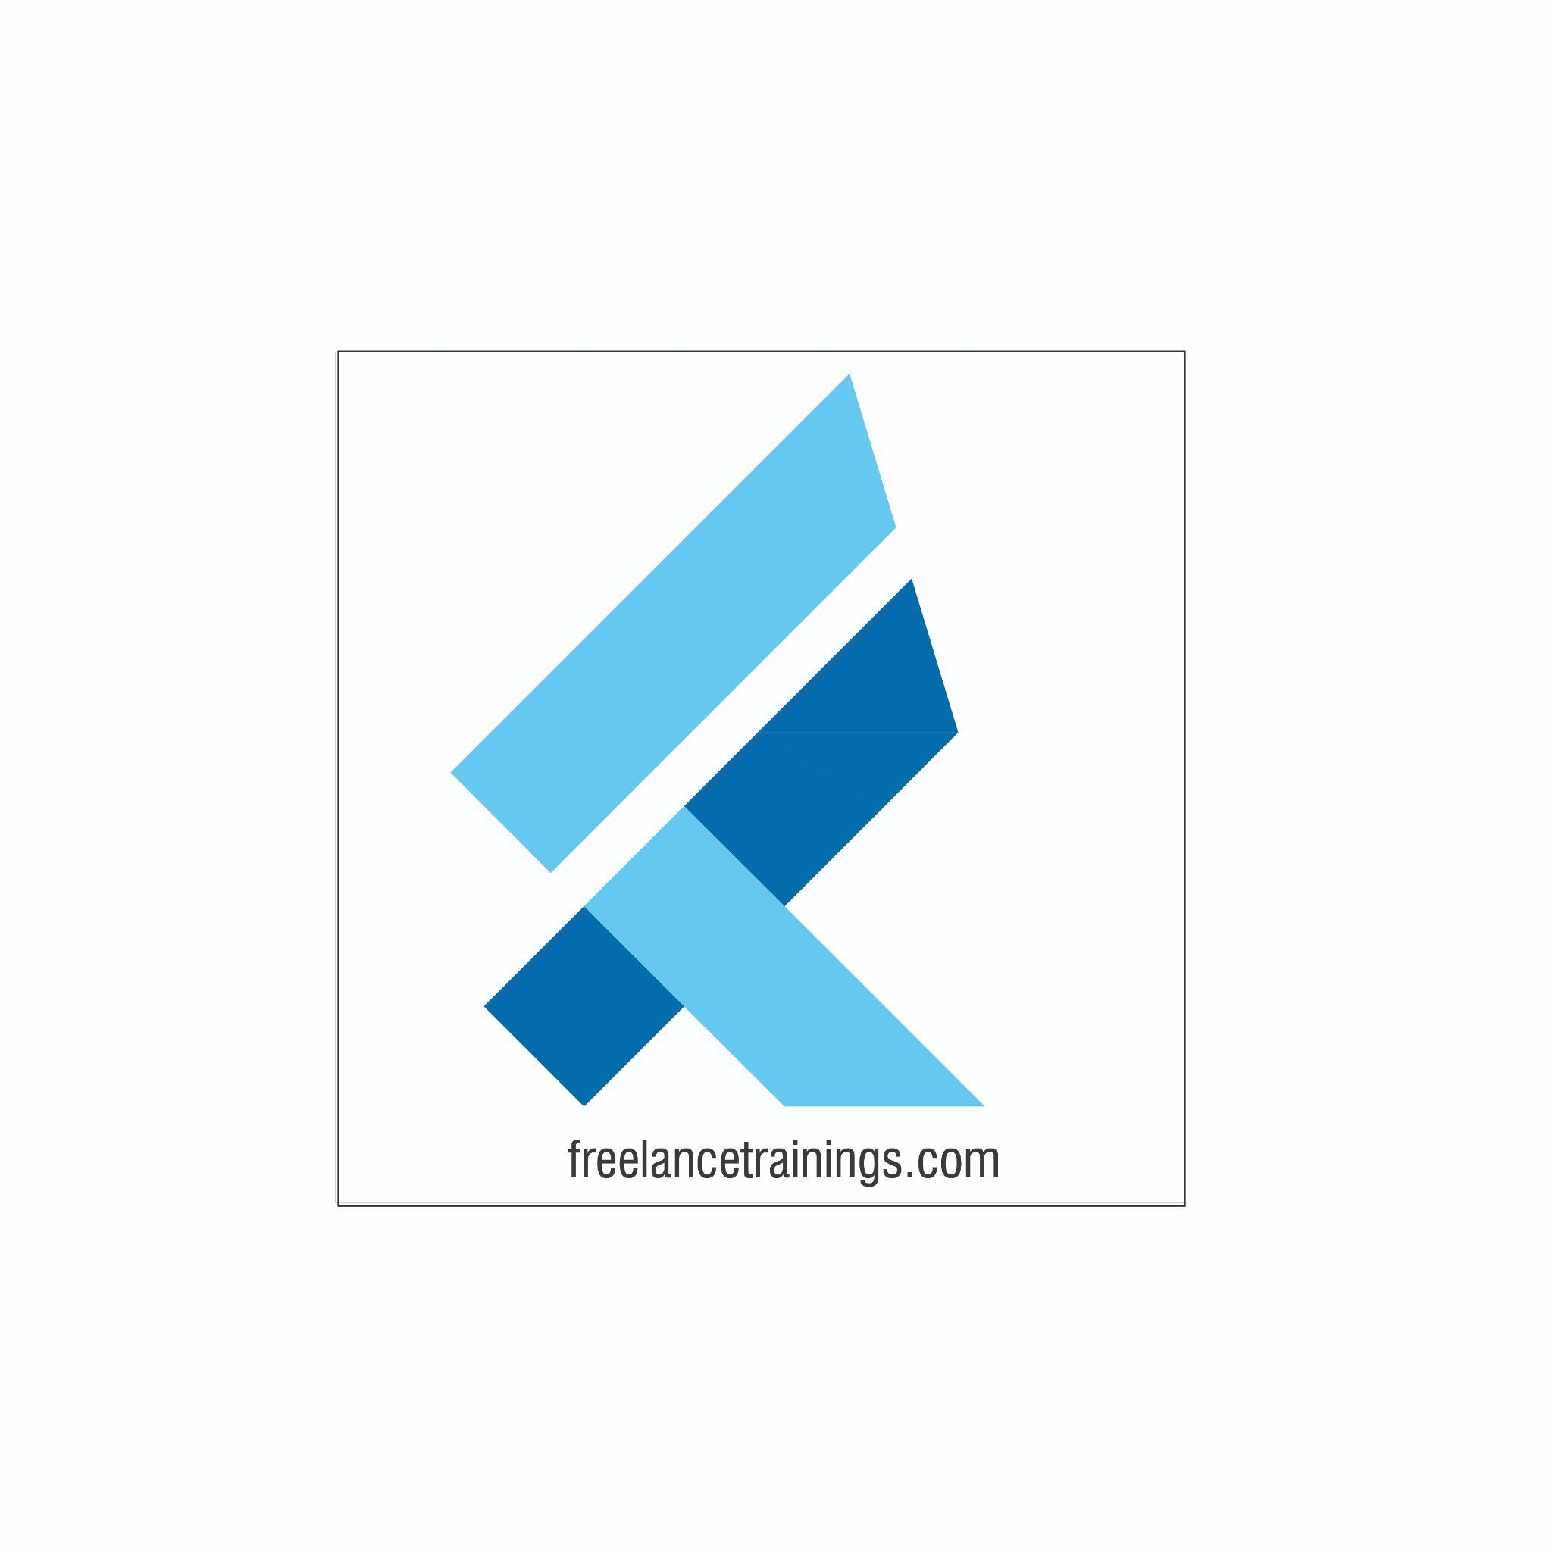

Telesales Workshop

Duration: 1 Day

No of Participants: 25-30 Pax

Timing: 9:30 A.M- 5:30 P.M

Target Audience

* Individual Contributors
* Supervisors
* Early Team Managers
* Employees of Telesales Department

Workshop Objectives

* Introduction to Telesales
* The Telesales Process
* Mastering the Sales Pitch
* Understanding Customer Needs
* Product Pitching & Handling sales Objections
* Common Telesales Etiquettes

Workshop Outline

|  |  |  |
| --- | --- | --- |
| **Sr. No.** | **Time** | **Topic** |
| 1 | 9:30- 10:15 AM | **What’s In It for Me**   * Workshop Intro & Agenda * Ground Rules * Icebreaker * Facilitator Intro * Participant Intro & Expectations |
| 2 | 10:15- 10:30 AM | **Pre-Training Assessment** |
| 3 | 10:30- 11:15 AM | **Introduction to** **Telesales**   * Understanding the Role of Telesales in the Sales Process * Key Differences Between Telesales and In-person Sales * Benefits and Challenges of Telesales * Cultivating a Positive Attitude for Telesales |
| 4 | 11:15 -11:30 AM | **First Tea Break** |
| 5 | 11:30 -12:15 PM | **The Telesales Process**   * Understanding the Sales Funnel * Suspects and Prospects * Lead Categories- Hot, Warm & Cold * Engaging and Qualifying Prospects * Techniques for Handling Gatekeepers |
| 6 | 12:15 - 01:00 PM | **Mastering the Sales Pitch**   * Tele calling Script- Need & Reason * Components of a tele calling script * Greetings over the call * Generating Interest * Generating appointment/ Opportunity |
| 8 | 1:00 – 1:45 PM | **Lunch Break** |
| 7 | 1:45 – 2:30 PM | **Understanding Customer Needs**   * Active Listening Skills * Art of Effective Questioning and Probing * Developing a Confident and Professional Tone of Voice * Doubts Clarifying & Reconfirm |
| 9 | 2:30 – 3:30 PM | **Product Pitching & Handling sales Objections**   * Product Pitching- Features & Benefits * Identifying Common Customer Objections * Effective Techniques for Handling Objections * Turning Objections into Opportunities |
| 10 | 3:30 – 4:00 PM | **Common Telesales Etiquettes**   * Understanding and Adhering to Legal and Ethical Guidelines * Respecting Customer Privacy and Consent * Building Trust and Credibility with Integrity * Tone & Pitch * Volume & Clarity |
| 11 | 4:00 – 4:15 PM | **Second Tea Break** |
| 13 | 4:15 - 4:30 PM | **Recap** |
| 14 | 4:30- 4:45 PM | **Post Training Assessment** |
| 15 | 4:45- 5:30 PM | **Closing**   * Feedback forms * Q&A (If any) * Closing Video (If any) * Group Photo |

*This Workshop outline is based on the industry best practices and will be customised after discussion with the client.*