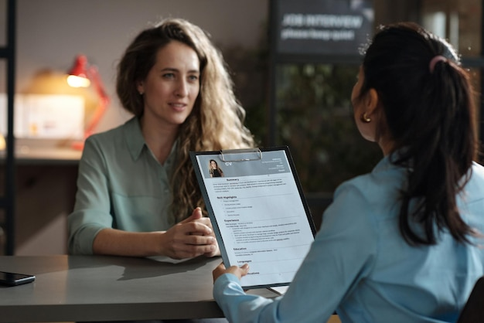

**Resume Writing & Interview Skills Workshop**

“There are no limits that you can accomplish except the limits that you place on your own thinking.” ― 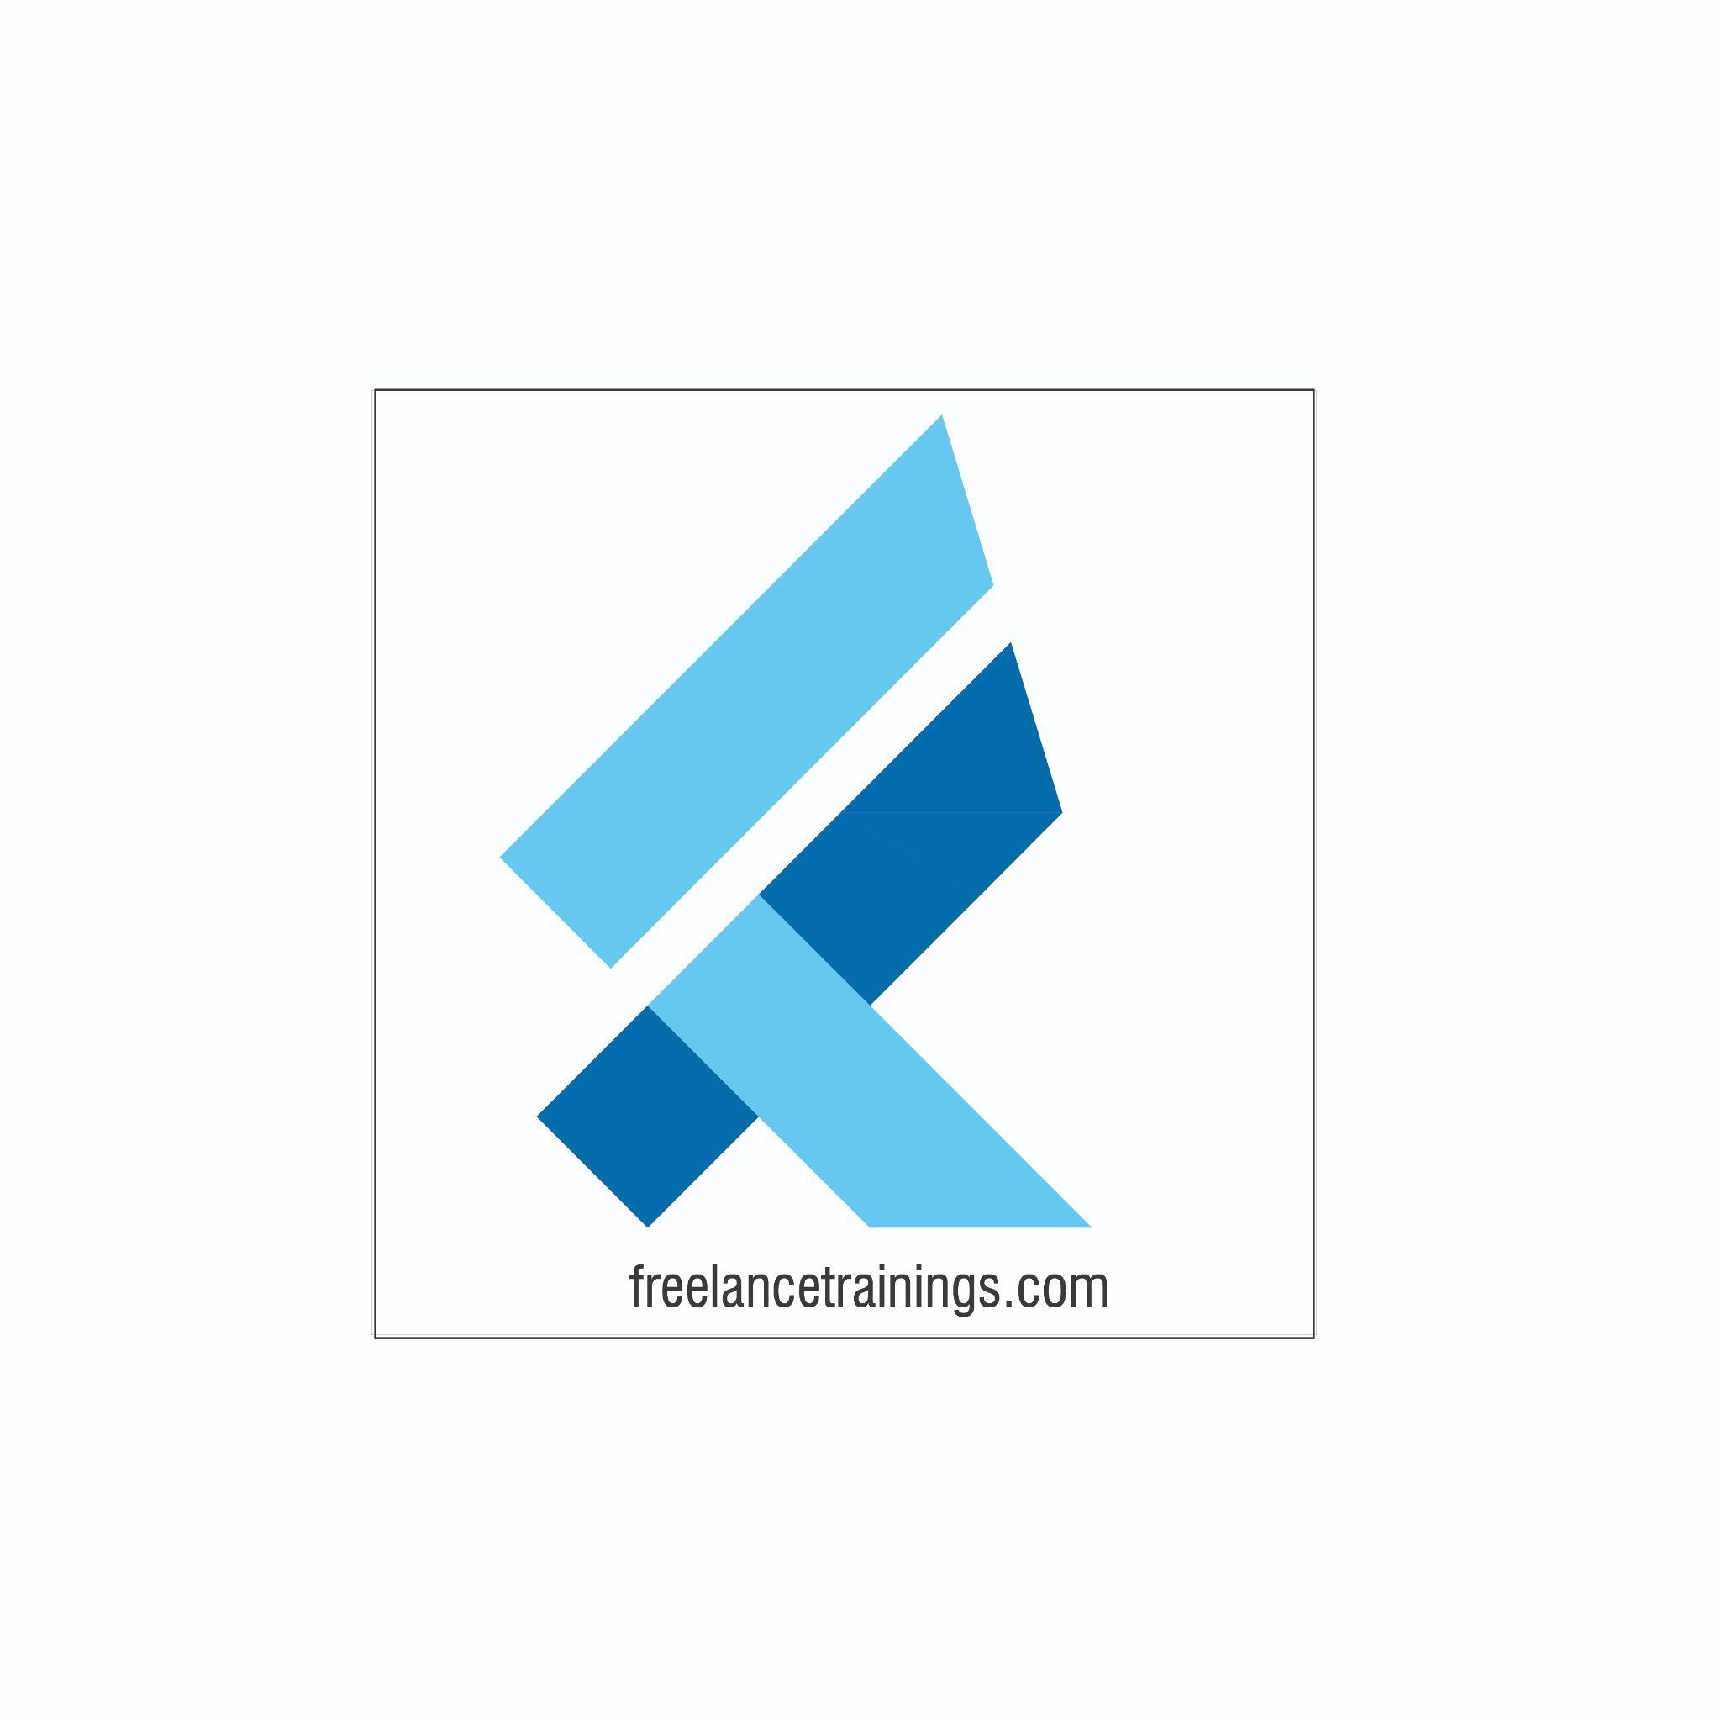Brian Tracy

Resume Writing & Interview Skills Workshop

Duration: 1 Day

No of Participants: 25-30 Pax

Timing: 9:30 A.M- 5:30 P.M

Target Audience

* Final year Students
* Professors/ Lecturers/ Trainers
* Placement Officers
* New Joiners/ Freshers

Workshop Objectives

* Understanding Resume
* Resume Making
* Job Description & Their Importance
* Importance of cover letter & group discussion
* Group Discussion Practice
* Interview Skills
* Interview Process
* Creating LinkedIn Profile
* Social Media Etiquette
* Tips for Interviews



Workshop Outline

|  |  |  |
| --- | --- | --- |
| **Day 1** | | |
| **Sr. No.** | **Time** | **Topic** |
| 1 | 9:30-10:15 AM | **What’s In It for Me** • Workshop Intro & Agenda • Ground Rules • Icebreaker • Facilitator Intro • Participant Intro & Expectations |
| 2 | 10:15- 10:30 AM | **Pre-Training Assessment** |
| 3 | 10:30- 11:15 AM | **Understanding Resume**   * What is Resume? * Key Components of a Resume * Difference between Resume, CV Or Biodata |
| 4 | 11:15 -11:30 AM | **First Tea Break** |
| 5 | 11:30 -12:00 PM | **Resume Making Activity**   * Types of Resume & Layouts * Important Part of Resume & Examples * Resume Writing Mistakes * How to review Resume |
| 6 | 12:00 - 12:30 PM | **Job Descriptions**   * Understanding Job Descriptions * Key Components of Job Description (JD) * Why Customising Resumes to JD * How to Customise Resumes as per JD |
| 7 | 12:30 - 1:15 PM | **Cover Letter & Group Discussion**   * Understanding Cover Letter * Key Components of Cover Letter * Tips for effective Cover Letters * What is Group Discussion? * Importance of Group Discussions * Key Features of Group Discussion * Tips for Group Discussion |
| 8 | 1:15 – 2:00 PM | **Lunch Break** |
| 9 | 2:00 – 2:15 PM | **Group Discussion Activity** |
| 10 | 2:15 – 3:15 PM | **Interview & Interview Process**   * What is Interviewing Skills? * Common Challenges Faced * Types of Interviews * Benefits of Interview * Skills that Employers look for * Understanding Interview Process? * Pre-Interview Preparation & Benefits * STAR Model Technique * Tips for interview |
| 11 | 3:10 – 4:00 PM | **Interview Practice** |
| 12 | 4:00 – 4:15 PM | **Second Tea Break** |
| 13 | 4:15 – 4:45 PM | **LinkedIn Profile & Social Media Etiquette**   * Understanding LinkedIn * LinkedIn Profile * How to make LinkedIn Profile * Social Media Etiquettes for Freshers |
| 14 | 4:45 - 5:00 PM | **Recap** |
| 15 | 5:00- 5:15 PM | **Post Training Assessment** |
| 16 | 5:15- 5:30 PM | **Closing**   * Feedback forms * Q&A (If any) * Closing Video (If any) * Group Photo |

*This Workshop outline is based on the industry best practices and will be customised after discussion with the client.*