

**Collobration Skills Workshop**

"Great things in business are never done by one person, they are done by a team of people" -Steve Jobs

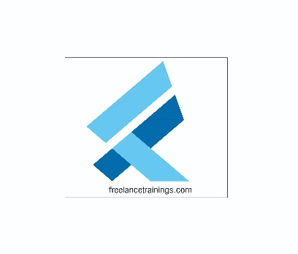

Collaboration Skills Workshop

Duration: 1 Day

No of Participants: 25-30 Pax

Timing: 9:30 A.M- 5:30 P.M

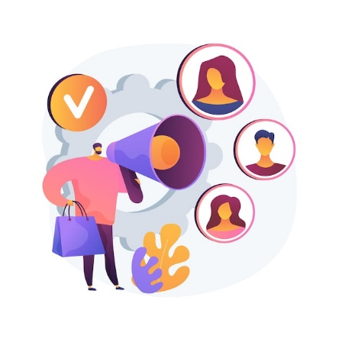Target Audience

* Individual Contributors
* Supervisors
* Early Team Managers
* Employees of any department
* Cross Functional Teams

Workshop Objectives

* Understanding collaboration skills
* Elements of collaboration skills
* Essential collaboration skills
* Building trust in collaboration
* Building virtual collaboration skills
* Barriers to effective collaboration



Workshop Outline

|  |  |  |
| --- | --- | --- |
| **Sr. No.** | **Time** | **Topic** |
| 1 | 9:30- 10:15 AM | **What’s In It for Me**   * Workshop Intro & Agenda * Ground Rules * Icebreaker * Facilitator Intro * Participant Intro & Expectations |
| 2 | 10:15- 10:30 AM | **Pre-Training Assessment** |
| 3 | 10:30- 11:15 AM | **Collaboration Skills**   * What is a collaboration * Types of collaboration * Impact of Collaboration on Individuals & Teams * Myths related to conflicts |
| 4 | 11:15 -11:30 AM | **First Tea Break** |
| 5 | 11:30 -12:15 PM | **Elements of Collaboration Skills**   * 5 Elements of Collaboration Skills * Collaboration Vs Teamwork * How to Make Collaboration Work: 6 Predictable Stages * Qualities of a collaborator |
| 6 | 12:15 - 01:00 PM | **Essential Collaboration Skills**   * Emotional Intelligence * Effective communication and active listening. * Building empathy * Clear. Concise & solution-oriented communication |
| 8 | 1:00 – 1:45 PM | **Lunch Break** |
| 7 | 1:45 – 2:30 PM | **Building Trust in Collaboration**   * The role of trust in collaboration. * Team-building activities to foster trust and cooperation. * Strategies for building strong cross-functional teams. |
| 9 | 2:30 – 3:30 PM | **Building Virtual Collaboration**   * Extra challenges of virtual collaboration * Virtual collaboration tools ideas and suggestions * Good virtual communication practices |
| 10 | 3:30 – 4:00 PM | **Barriers to Effective collaboration**   * Common Barriers in collaboration * Rewarding Team Collaboration |
| 11 | 4:00 – 4:15 PM | **Second Tea Break** |
| 13 | 4:15 - 4:30 PM | **Recap** |
| 14 | 4:30- 4:45 PM | **Post Training Assessment** |
| 15 | 4:45- 5:30 PM | **Closing**   * Feedback forms * Q&A (If any) * Closing Video (If any) * Group Photo |

*This Workshop outline is based on the industry best practices and will be customised after discussion with the client.