

**Induction Workshop**

" While you can think in terms of efficiency in dealing with time ,a principle -centered person thinks in terms of effectiveness in dealing with people ”.

– Stephen R Covey

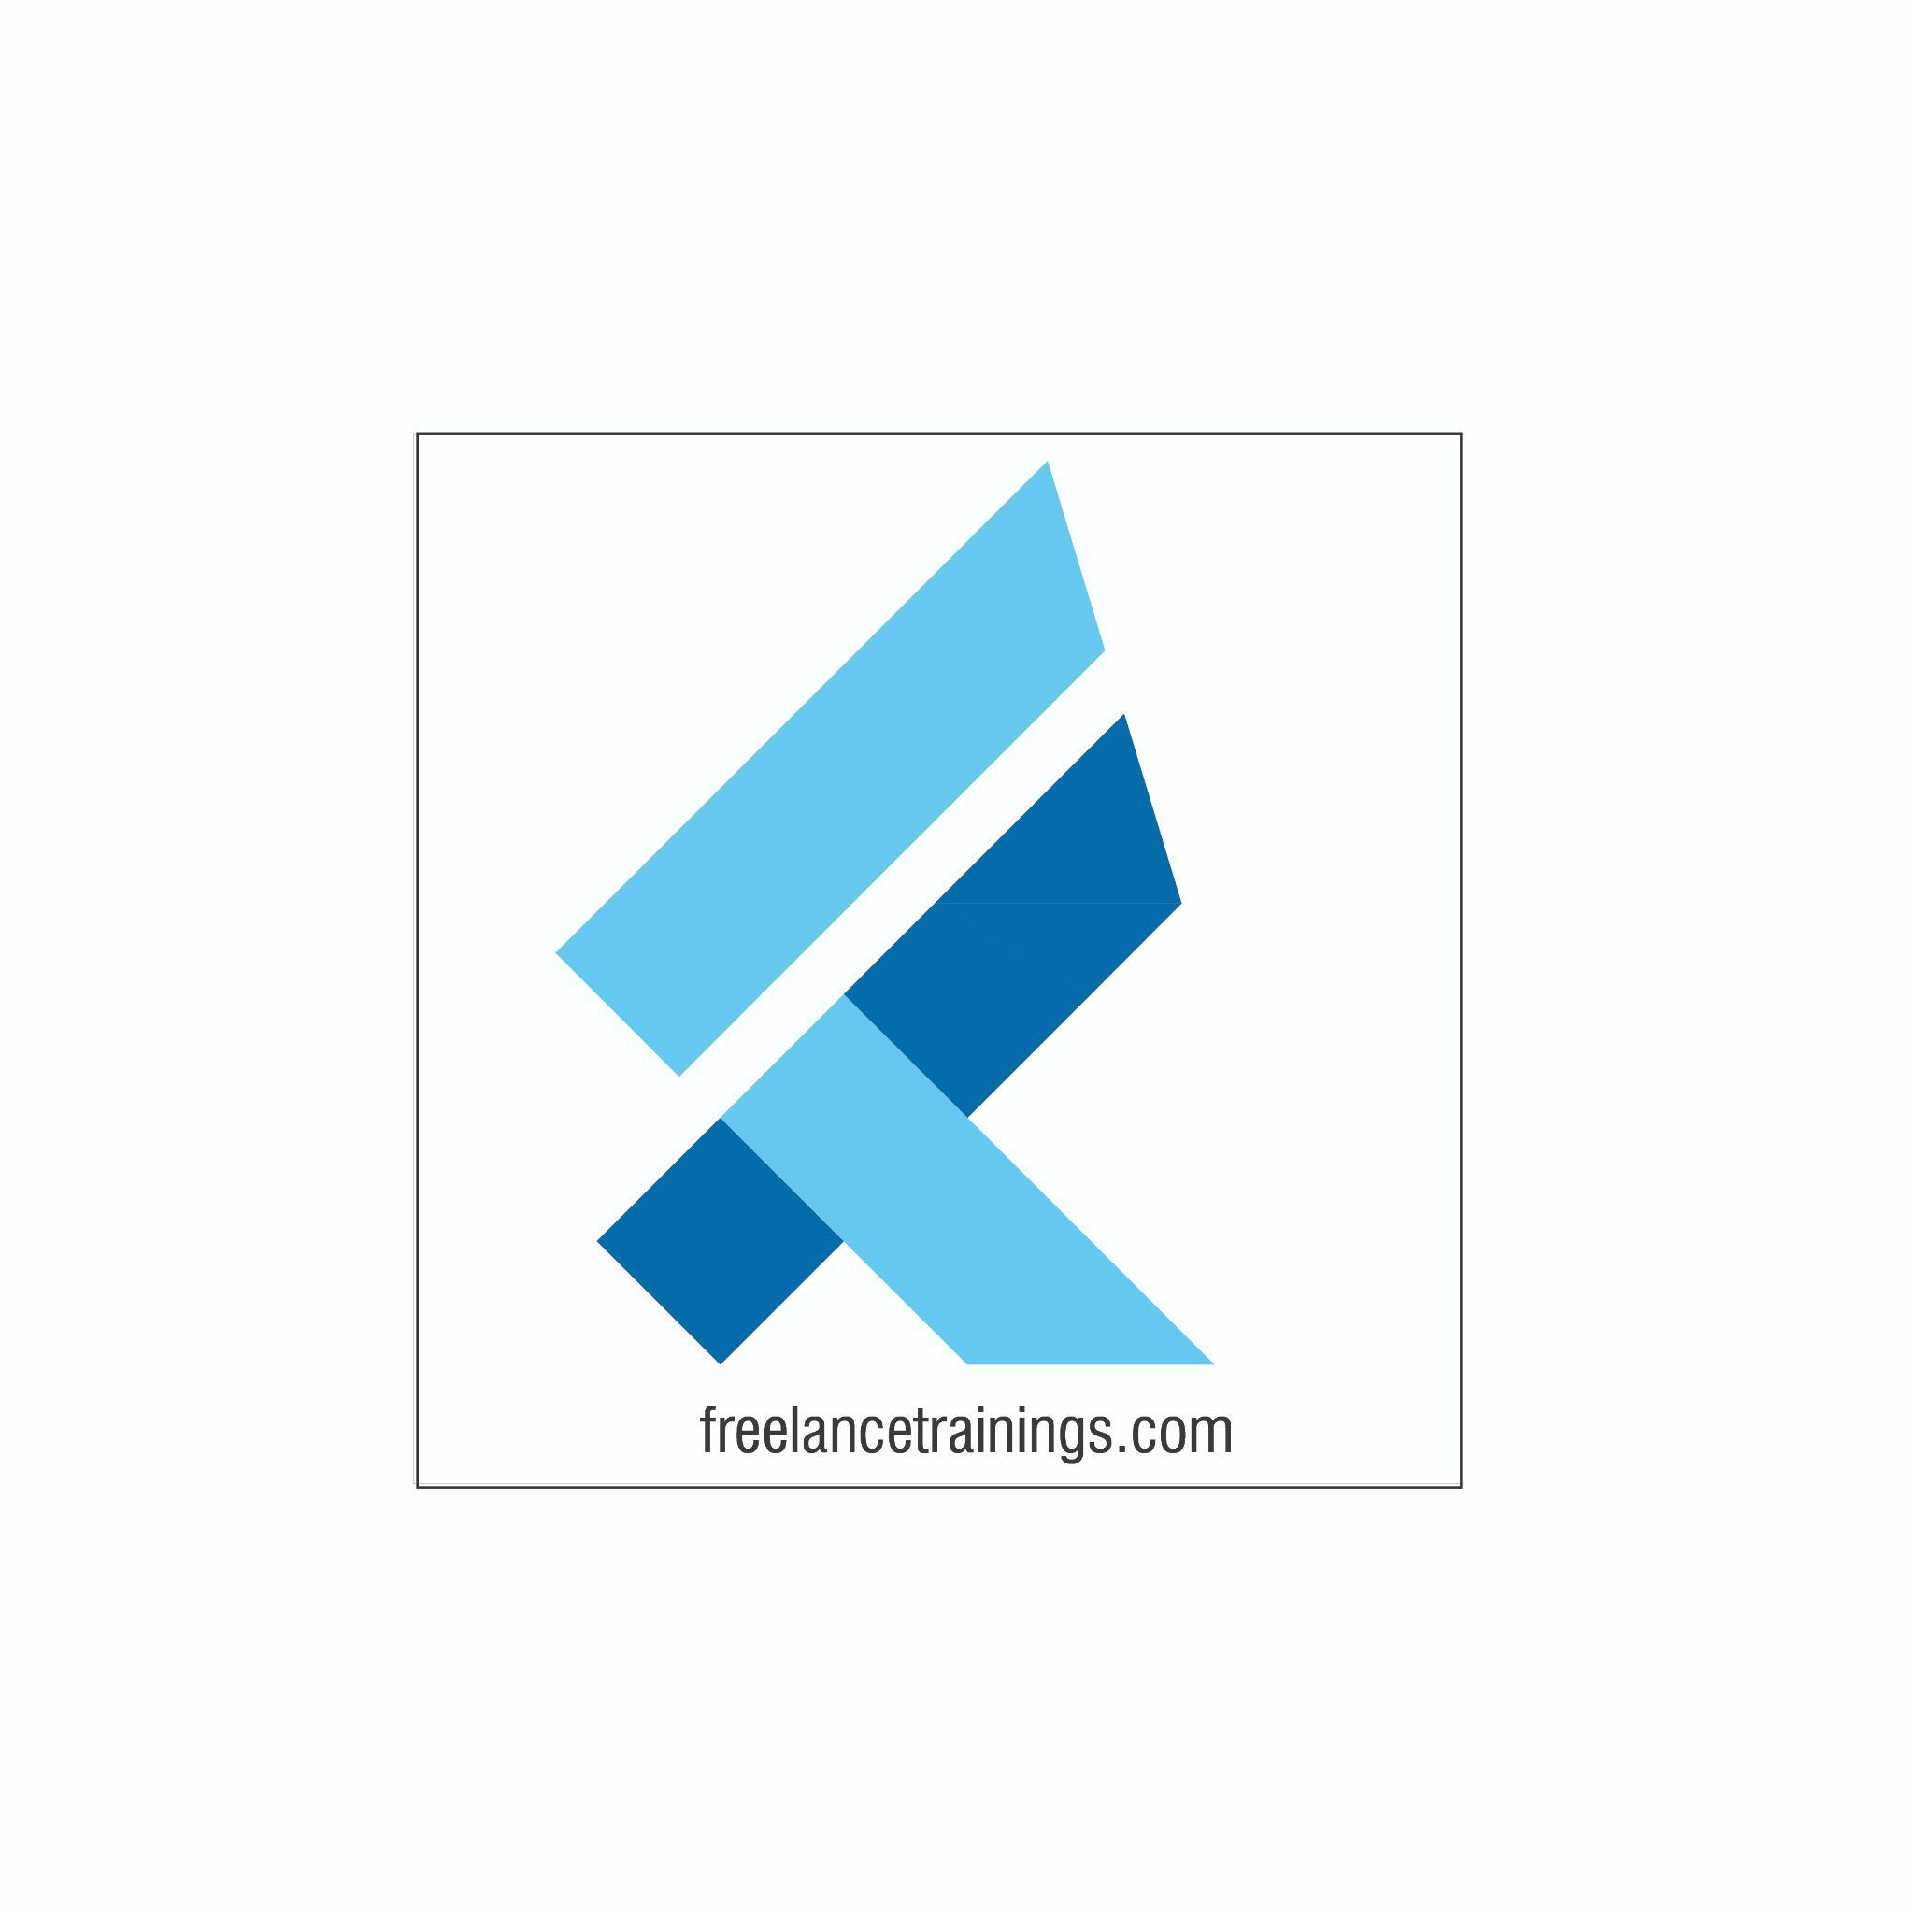

Presentation Skill Workshop

Duration: 2 Days

No of Participants: 25-30 Pax

Timing: 9:30 A.M- 5:30 P.M

Target Audience

* Individual Contributors
* Supervisors
* New Joiners
* Employees of any department

Workshop Objectives

* Understanding Personal Effectiveness
* Building an attitude of Ownership & Accountability
* Impactful Communication
* Building Fool Proof Communication
* Goal Setting
* Being a Team Player- Interpersonal Skills
* Managing time & Prioritisation
* Managing Stakeholders
* First Impression is the last Impression- Grooming, Etiquette & Body Language
* Email Etiquette

Workshop Outline

|  |  |  |
| --- | --- | --- |
| **Day 1** | | |
| **Sr. No.** | **Time** | **Topic** |
| 1 | 9:30 – 10:15 AM | **What’s In It for Me**   * Workshop Intro & Agenda * Ground Rules * Icebreaker * Facilitator Intro * Participant Intro & Expectations |
| 2 | 10:15 -10:30 AM | **Pre-Training Assessment** |
| 3 | 10:30 -11:15 AM | **Understanding Soft Skills & Personal Effectiveness**   * Soft Skills & Importance * Personal Effectiveness * Benefits of Personal Effectiveness (Self + Organisation) * Building Personal Excellence (ASK)- Attitude, Skills, Knowledge) |
| 4 | 11:15- 11:30 AM | **First Tea Break** |
| 5 | 11:30- 12:15 PM | **Building an attitude of Ownership & Accountability**  • Understanding Ownership • Developing a Proactive approach-Circle of Control • Building a solution Centric • Avoid Blame Game- Walking the Extra Mile |
| 6 | 12:15 -1:15 PM | **Impactful Communication**   * Types of Communication (Assertive, Aggressive & Passive) * Pros & Cons of each Type * Developing assertive style of communication * Building Empathetic communication |
| 7 | 1:15 - 2:00 PM | **Lunch Break** |
| 8 | 2:00 - 2:15 PM | **Energiser** |
| 9 | 2:15 - 3:00 PM | **Building Fool Proof Communication**  • LADR Model of Communication • Listening Actively • Asking Questions (Open Vs Close ended) • Reconfirm |
| 10 | 3:00 – 3: 45 PM | **Goal Setting**   * Benefits of Setting Goals * Goal setting Mistakes * Goal Setting exercise * Making your Goals SMART (Specific, Measurable, Achievable, Realistic and Time Bound |
| 11 | 3:45 - 4:00 PM | **Second Tea Break** |
| 12 | 4:00- 4:30 PM | **Being a Team Player- Interpersonal Effectiveness**   * Understanding Interpersonal Effectiveness * Importance of the same- Individual & Organisation * Interpersonal Communication- Some Misconceptions * Ways to enhance Interpersonal skills |
| 13 | 4:30 – 4:45 PM | **Recap** |
| 14 | 4:45 - 5:00 PM | **Post Training Assessment** |
| 15 | 5:00 -5:30 PM | **Closing** • Q& A • Closing Video  • Homework for day 2 (Optional) |

\***This is an indicative outline based on Industry best practices and the same can be customised by the trainer as per the client’s need and discussion.**