

**Image Management Workshop-2 Days**

"You too are a brand, whether you know it or not, whether you like it or not" -Marc Ecko

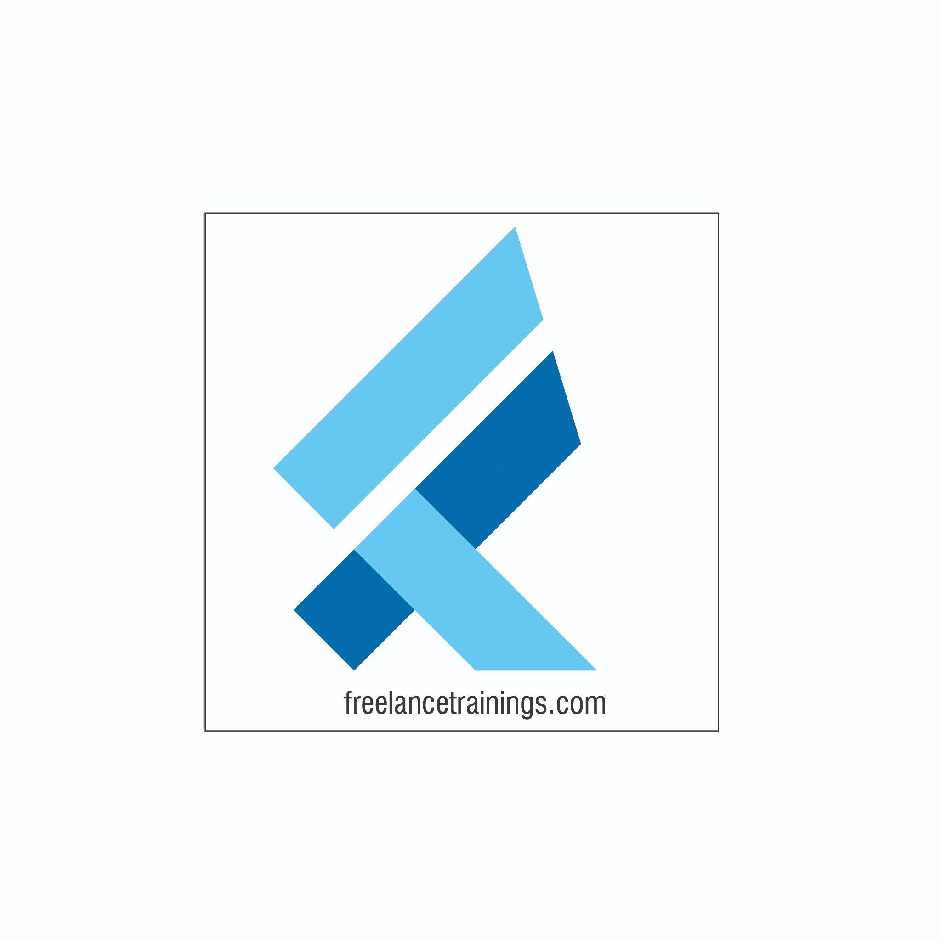

Image Management Workshop

Duration: 2 Days

No of Participants: 25-30 Pax

Timing: 9:30 A.M- 5:30 P.M

Target Audience

* Individual Contributors
* Supervisors
* Early Team Managers
* Employees of any department
* Sales & Marketing Teams

Workshop Objectives

* Understanding Image Management
* Building an Attitude of Ownership
* Nonverbal Communication
* Body Language
* Looks Matter
* Watch the Odour
* Email Etiquette
* Telephone & Meeting Etiquettes
* Social Etiquettes



Workshop Outline

|  |  |  |
| --- | --- | --- |
| Day 1 | | |
| **Sr. No.** | **Time** | **Topic** |
| 1 | 9:30-10:15 AM | **What’s In It for Me** • Workshop Intro & Agenda • Ground Rules • Facilitator Intro • Icebreaker + Participant Intro & Expectations |
| 2 | 10:15- 10:30 AM | **Pre-Training Assessment** |
| 3 | 10:30- 11:15 AM | **Understanding Image Management** • What is Image management • Components of Image Management • Benefits of Image Management to Individuals & Organizations |
| 4 | 11:15 -11:30 AM | **First Tea Break** |
| 5 | 11:30 - 12:30 PM | **Building an Attitude of Ownership** • Understanding Ownership • Developing a Proactive approach-Circle of Control • Building a solution Centric • Avoid Blame Game- Walking the Extra Mile |
| 6 | 12:30 - 1:15 PM | **Nonverbal Communication** • Mehrabian Model- (Visual, Vocal & Verbal) • Components of Visual • Body Language • Attire • Hygiene & Grooming |
| 7 | 1:15 - 2:00 PM | **Lunch Break** |
| 8 | 2:00 - 2:15 PM | **Energizer** |
| 9 | 2:15 - 3:15 PM | **Body Language (As per Indian Corporate Standard)** • Introduction • Greetings  • Handshake • Business Card Etiquette • Eye Contact • Personal Space |
| 10 | 3:15 - 4:00 PM | **Looks Matter** • Formal Dressing Males & Females • Casual Dressing • Accessories for Males & Females • Belts & Footwear • Some commonly observed rules |
| 11 | 4:00- 4:15 PM | **Second Tea Break** |
| 12 | 4:15- 4:45 PM | **Watch the Odor** • Knowing the body Odors • Bad Breath • Deo Vs Perfume • Some commonly observed rules |
| 13 | 4:45 - 5:00 PM | **Recap of Day 1** |
| 14 | 5:00 -5:30 PM | **Closing** • Q& A • Closing Video  • Homework for day 2 (Optional) |
| **Day 2** | | |
| **Sr. No.** | **Time** | **Topic** |
| 1 | 9:30-10:00 AM | **What’s In It for Me** • Recap of Day 1-Activity • Agenda |
| 2 | 10:00- 11:15 AM | **Vocal Communication** • Components of Voice • Choosing the right tone • Pitch & Pace of Voice • Listening with empathy |
| 3 | 11:15 -11:30 AM | **First Tea Break** |
| 4 | 11:30 - 1:00 PM | **Dining Etiquette** • Napkin Etiquettes • Cutlery Etiquettes  • Sitting arrangement • Drinking Soup • American Vs Continental |
| 5 | 1:00 - 1:45 PM | **Lunch Break** |
| 6 | 1:45 - 2:00 PM | **Energizer** |
| 7 | 2:00 - 3:30 PM | **Email Etiquette** • Email Addressing • Subject Line • Salutation • Email Body, Signature & Attachment • Best Practice |
| 8 | 3:30- 4:00 PM | **Telephone & Meeting Etiquettes** • Mobile Phone  • Conference call • Web Calls & meetings • Physical Meeting’s |
| 9 | 4:00- 4:15 PM | **Second Tea Break** |
| 10 | 4:15- 4:30 PM | **Social Etiquettes** • Punctuality • Courtesy • Gifting & Tipping |
| 11 | 4:30 - 4:45 PM | **Post Training Assessment** |
| 12 | 4:45 -5:30 PM | **Closing** • Feedback forms • Q& A (If any) • Closing Video (If any) • Group Photo |

*This Workshop outline is based on the industry best practices and will be customised after discussion with the client.