

**Customer Service Workshop**

“If you don’t take care of your customer, your competitor will.”

– Bob Hooey

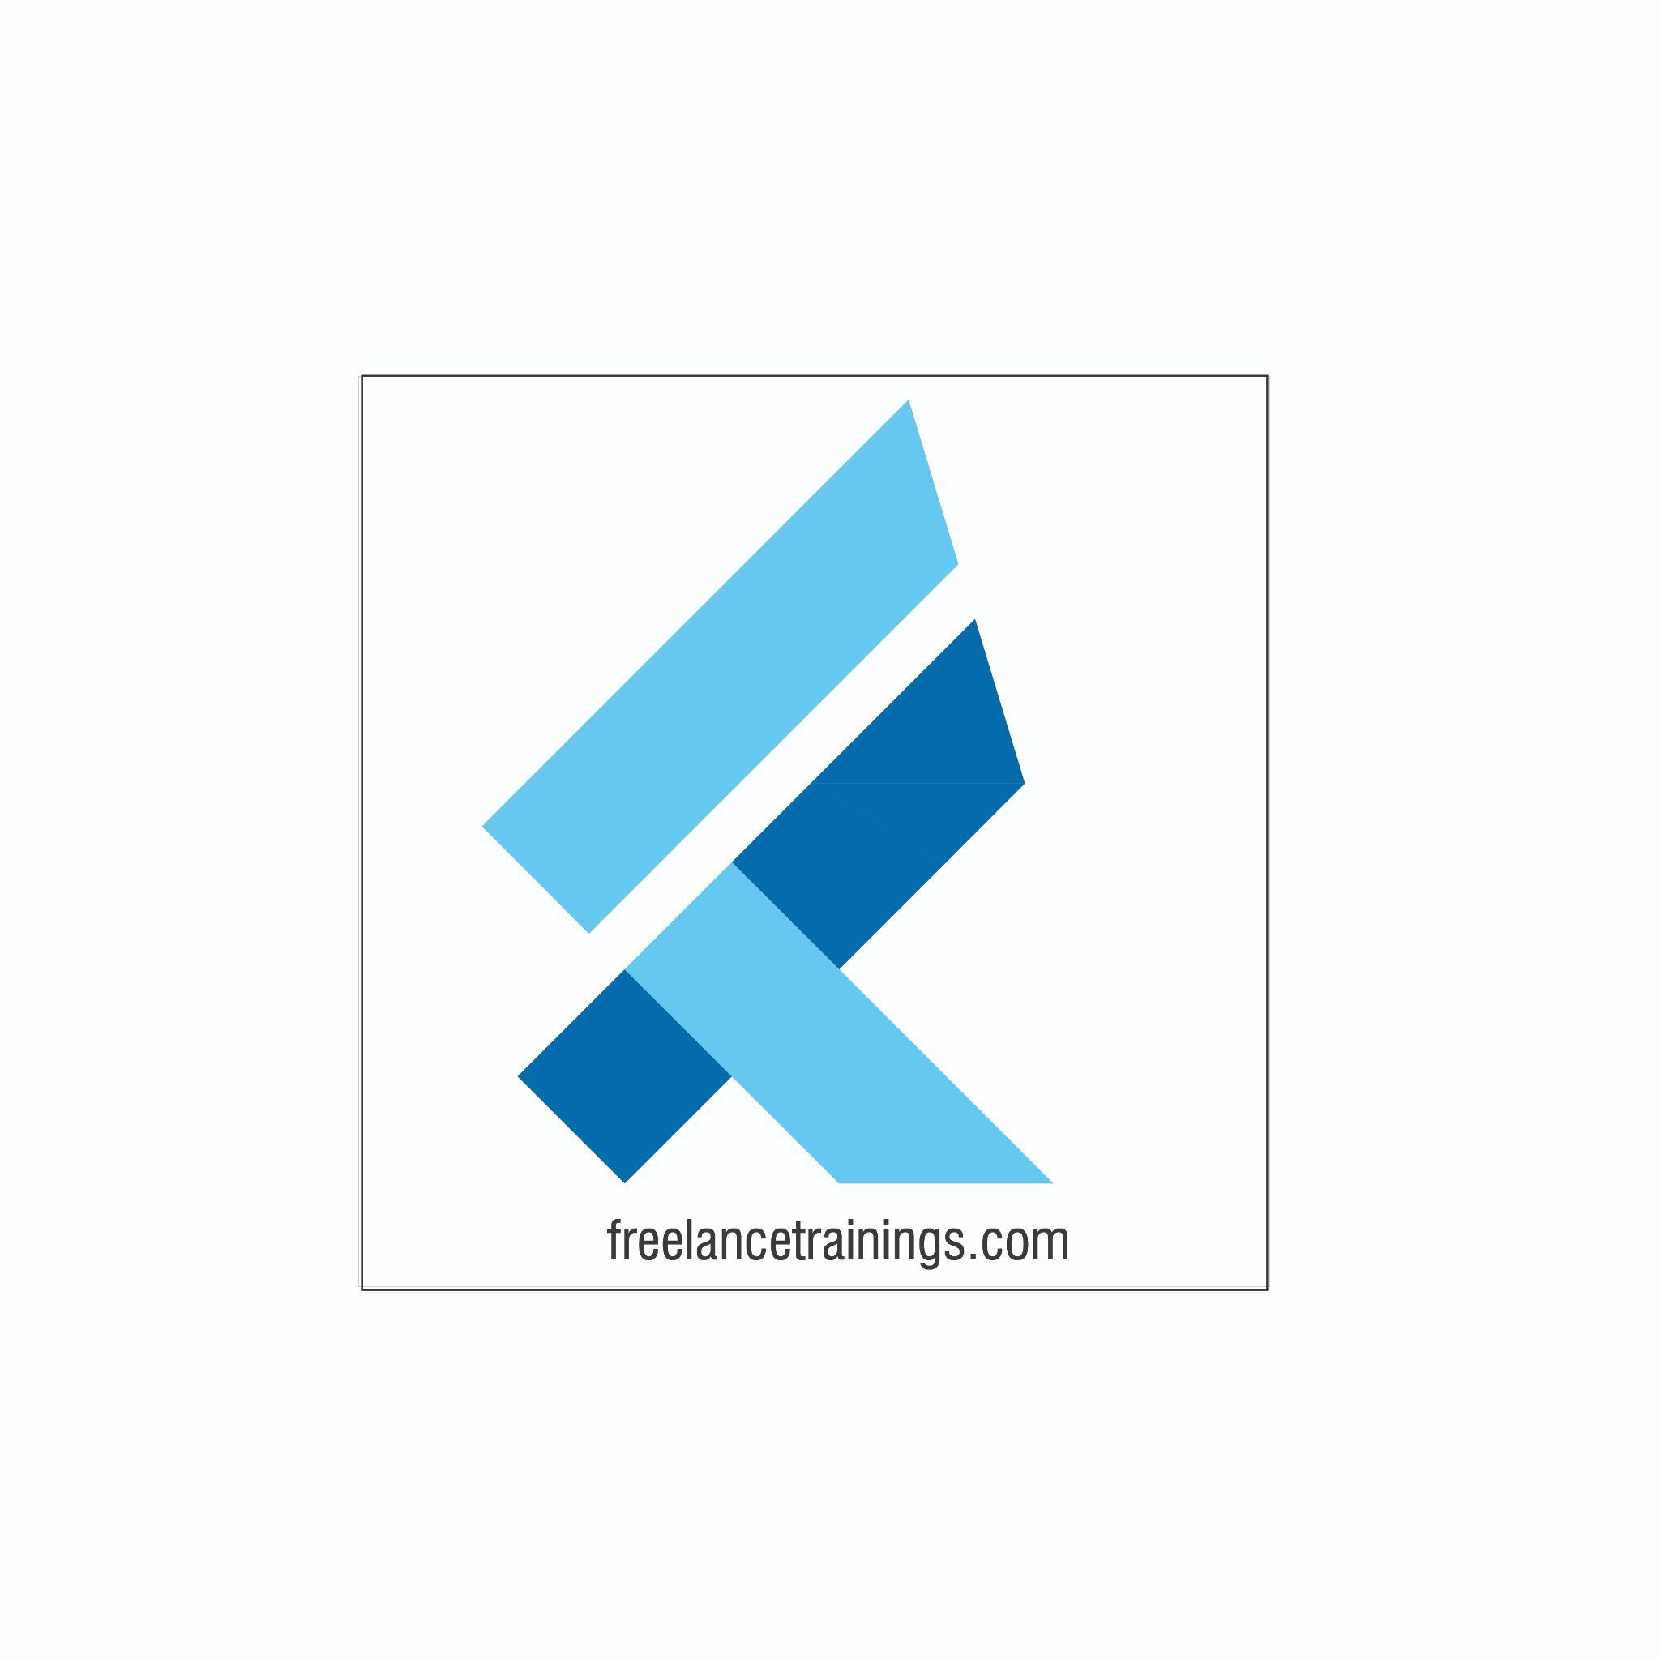

Customer Service Workshop

Duration: 2 Days

No of Participants: 25-30 Pax

Timing: 9:30 A.M- 5:30 P.M

Target Audience

* Individual Contributors
* Early Managers
* Supervisors
* Employees of any department

Workshop Objectives

* Understanding Customer Service Essentials
* Building an Attitude of Ownership
* Moment of Truth
* Understanding your customers (Needs)
* Impactful Communication
* Customer Service Model
* Saying No to a customer
* Handling an Irate Customer
* Net Promoter Score
* Tips for world class Customer Service

Workshop Outline

|  |  |  |
| --- | --- | --- |
| **Day-1** | | |
| **Sr. No.** | **Time** | **Topic** |
| 1 | 9:30-10:15 AM | **What’s In It for Me**   * Workshop Intro & Agenda * Ground Rules * Icebreaker * Facilitator Intro * Participant Intro & Expectations |
| 2 | 10:15- 10:30 AM | **Pre-Training Assessment** |
| 3 | 10:30- 11:15 AM | **Module-1 - Customer Service Essentials**   * What do People Remember and Why. * What is Customer service * Importance in Customer Service- Self * Benefits of great customer service to Organisation |
| 4 | 11:15 – 11:30 AM | **First Tea Break** |
| 5 | 11:30 – 12:30 PM | **Module-2 - Building an attitude of Ownership & Accountability**   * Understanding Ownership * Developing a Proactive Approach-Circle of Control * Building a solution Centric * Avoid Blame Game- Walking the Extra Mile |
| 6 | 12:30 – 1:15 PM | **Module-3 - Moment of Truth**   * Understanding Moment of Truth * Moment of Misery Vs Moment of Magic * Exploring the customer delight moments * Building The Tragics into Magics |
| 7 | 1:15 – 2:00 PM | **Lunch Break** |
| 8 | 2:00 - 2:15 PM | **Energiser** |
| 9 | 2:15- 3:15 PM | **Module-4 - Understanding Your Customer (Need)**   * Creating a safe and respectful work environment * Active Listening * Asking Questions (Open Ended Vs Close ended) * Clarifying doubts * Reconfirm the understanding |
| 10 | 3:15- 4:15 PM | **Module-5 - Impactful Communication**   * Types of Communication (Passive, Aggressive & Assertive) * Understand Assertive communication * Following an Assertive communication style |
| 11 | 4:15 - 4:30 PM | **Second Tea Break** |
| 12 | 4:30- 5:00 PM | **Recap Day-1** |
| 13 | 5:00 - 5:30 PM | **Closing**   * Q& A * Closing Video * Homework for day 2 (Optional) |
| **Day-2** | | |
| **Sr. No.** | **Time** | **Topic** |
| 1 | 9:30-10:00 AM | **What’s In It for Me**   * Recap of Day 1-Activity * Agenda |
| 2 | 10:00- 11:15 AM | **Module-6 – PRIDE Model of Customer Service**   * P-Personalise * R- Respect & Professionalism * I- Innovate & Improve * D- Develop Yourself * E- Empathy |
| 3 | 11:15 – 11:30 AM | **First Tea Break** |
| 4 | 11:30 – 12:15 PM | **Module-7 – Practicing Empathy**   * Understanding Empathy * Benefits of Empathy * Ways to practice Empathy * Left Hanging Activity |
| 5 | 12:15 – 1:15 PM | **Module-8 - Saying No to a customer**   * Why Saying No to Customer * How to say No to the customer. * Techniques to say no * Role Plays & Practice |
| 6 | 1:15 – 2:00 PM | **Lunch Break** |
| 7 | 2:00 - 2:15 PM | **Energiser** |
| 8 | 2:15– 3:15 PM | **Module-9 - Dealing with an Irate Customer**   * Help him empty the cup. * Providing solution to the customer * Closing the interactive with a reassurance and positive words. * Next Steps to be adhered |
| 5 | 3:15 – 4:15 PM | **Module-10 - Net Promoter Score(NPS)**   * What is NPS * Importance of NPS * How to calculate NPS * Promoters Vs Detractors * Tips for World class customer service |
| 12 | 4:15- 4:30 PM | **Recap Day-1 & Day-2** |
| 12 | 4:30- 4:45PM | **Post Training Assessment** |
| 13 | 4:45 - 5:30 PM | **Conclusion/ Closing**   * Summary of key points * Feedback forms * Q&A session * Closing Video (If any) * Group Photo |

*This Workshop outline is based on the industry best practices and will be customised after discussion with the client. *