

**Customer Service Workshop**

“If you don’t take care of your customer, your competitor will.”

– Bob Hooey

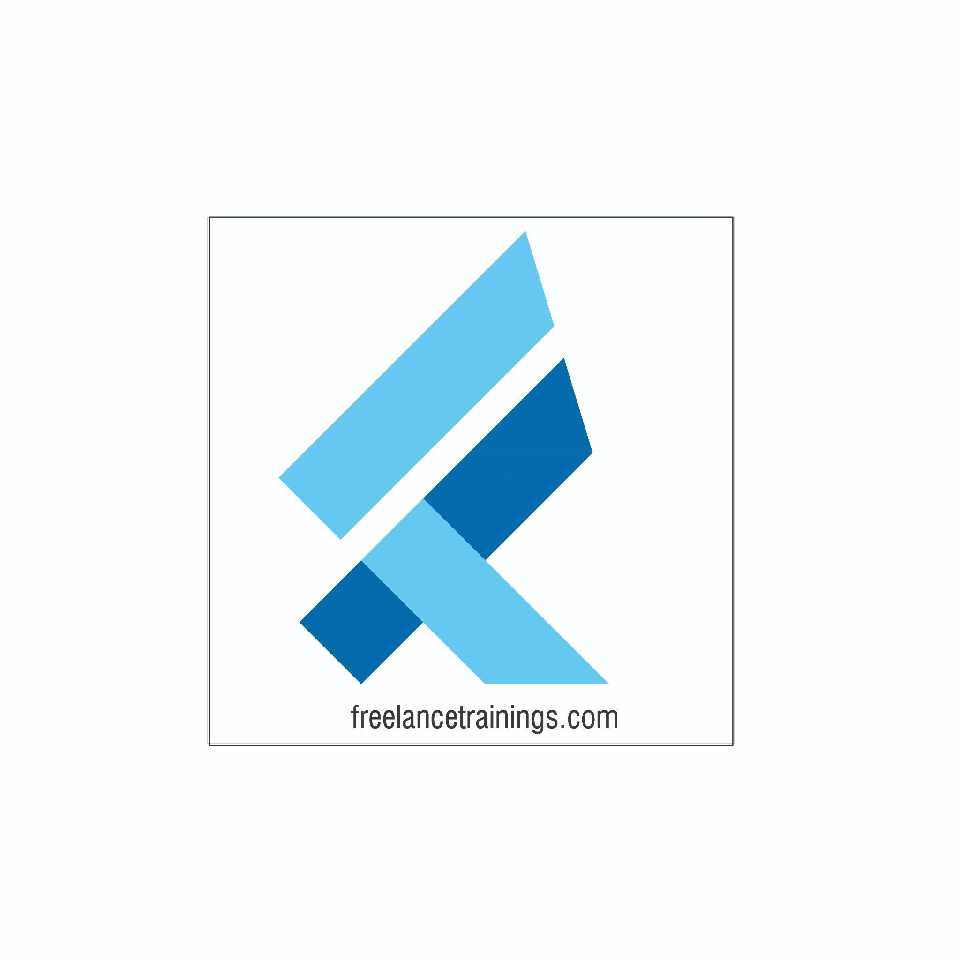

Customer Service Workshop

Duration: 1Day

No of Participants: 25-30 Pax

Timing: 9:30 A.M- 5:45 P.M

Target Audience

* Individual Contributors
* Early Managers
* Supervisors
* Employees of any department

Workshop Objectives

* Customer Service Essentials
* Building an attitude of Ownership & Accountability
* Moment of Truth
* Understanding Customer Needs
* Dealing with an Irate Customer
* Customer Service Professionals



Workshop Outline

|  |  |  |
| --- | --- | --- |
| **Sr. No.** | **Time** | **Topic** |
| 1 | 9:30-10:15 AM | **What’s In It for Me Day**   * Workshop Intro & Agenda * Ground Rules * Icebreaker * Facilitator Intro * Participant Intro & Expectations |
| 2 | 10:15- 10:30 AM | **Pre-Training Assessment** |
| 3 | 10:30- 11:15 AM | **Customer Service Essentials**   * What do People Remember and Why. * What is Customer service * Importance in Customer Service- Self * Benefits of great customer service to Organisation |
| 4 | 11:15 – 11:30 AM | **First Tea Break** |
| 5 | 11:30 – 12:30 PM | **Building an attitude of Ownership & Accountability**   * Understanding Ownership * Developing a Proactive Approach-Circle of Control * Building a solution Centric * Avoid Blame Game- Walking the Extra Mile |
| 6 | 12:30 – 1:15 PM | **Moment of Truth**   * Understanding Moment of Truth * Moment of Misery Vs Moment of Magic * Exploring the customer delight moments * Building The Tragics into Magics |
| 7 | 1:15 – 2:00 PM | **Lunch Break** |
| 8 | 2:00 - 2:15 PM | **Energiser** |
| 9 | 2:15- 3:00 PM | **Understanding Customer Needs**   * Creating a safe and respectful work environment * Active Listening * Asking Questions (Open Ended Vs Close ended) * Clarifying doubts * Reconfirm the understanding |
| 10 | 3:00- 3:45 PM | **Dealing with an Irate Customer**   * Help him empty the cup. * Providing solution to the customer * Closing the interactive with a reassurance and positive words. * Next Steps to be adhered |
| 11 | 3:45 - 4:00 PM | **Second Tea Break** |
| 12 | 4:00 - 4:45 PM | **Art of Saying No to the Customer**   * How to say No to the customer. * Techniques to say no * Service recovery Paradox * Being Empathetic to Customer |
| 13 | 4:45- 5:00 PM | **Recap** |
| 14 | 5:00- 5:15 AM | **Pre-Training Assessment** |
| 15 | 5:15 - 5:45 PM | **Conclusion/ Closing**   * Summary of key points * Feedback forms * Q&A session * Closing Video (If any) * Group Photo |

*This Workshop outline is based on the industry best practices and will be customised after discussion with the client. *