**Conducting Productive Meetings Workshop**

"Meetings should always have a clear purpose, a focused agenda, and a time limit. Otherwise, they can easily become a waste of time."

- Catherine Pulsifer

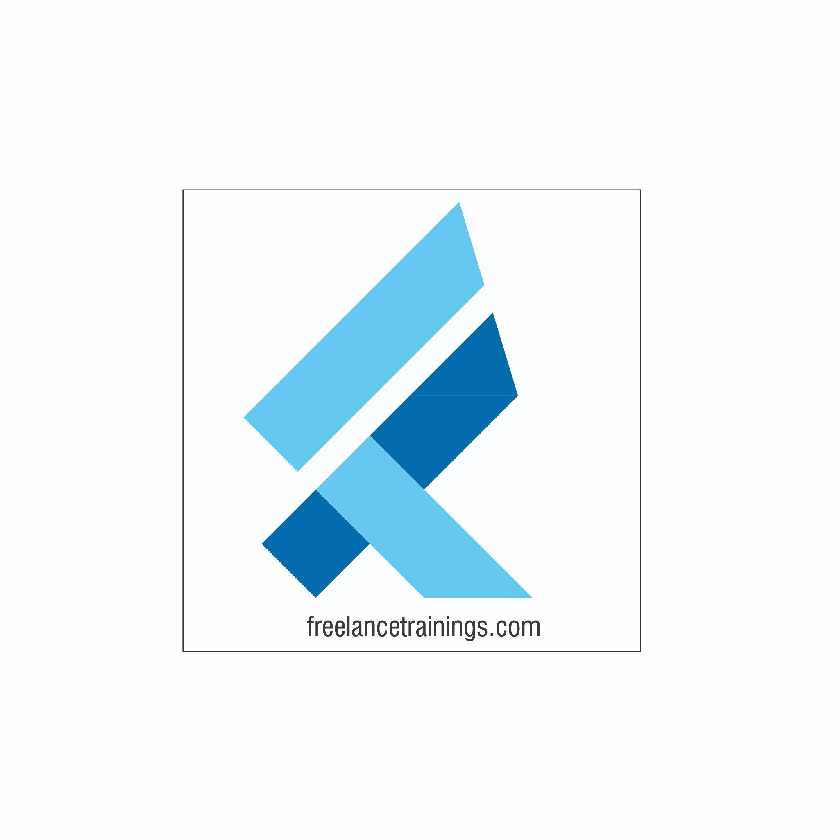

Conducting Productive Meetings Workshop

Duration: 3 Hrs

No of Participants: 25-30 Pax

Timing: 9:30 A.M- 12:30 P.M

Target Audience

* Individual Contributors
* Supervisors
* Early Team Managers
* Employees of any Department

Workshop Objectives

* Introduction to Productive Office Meetings
* Preparing for a Productive Meeting
* Roles and Responsibilities
* Conducting a Productive Meeting
* Post-Meeting Actions
* Cultural Sensitivity in Meeting
* Q&A Session

Workshop Outline

|  |  |  |
| --- | --- | --- |
| **Sr. No.** | **Time** | **Topic** |
| 1 | 9:30- 9:45AM | **Introduction to Productive Office Meetings**   * What are office Meetings * Importance of office meetings for Individuals and Teams * Common Meeting Challenges * Types of meetings |
| 2 | 9:45- 10:15 AM | **Preparing for a Productive Meeting (Pre Meeting)**   * Defining Meeting Objectives * Creating a Meeting Agenda * Inviting the Right Participants * Preparing Meeting Materials |
| 3 | 10:15- 11:00 AM | **Roles and Responsibilities**   * Role of the Meeting Organizer * Role of the Facilitator * Role of Participants |
| 4 | 11:00- 11:15 AM | **Break** |
| 5 | 11:15- 12:00 PM | **Conducting a Productive Meeting**   * Starting the Meeting * Staying on Agenda * Effective Communication * Managing Conflicts * Time Management |
| 6 | 12:00 -12:15 PM | **Post-Meeting Actions**   * Summarizing Meeting Outcomes * Assigning Action Items * Gathering Feedback * Follow-up Communication |
| 7 | 12:15 – 12:30 PM | **Cultural Sensitivity in Meeting**   * Cultural Considerations * Language and Communication |
| 8 | 12:30 - 12:35 PM | **Q&A Session**   * Participants Questions |

*This Workshop outline is based on the industry best practices and will be customised after discussion with the client.*