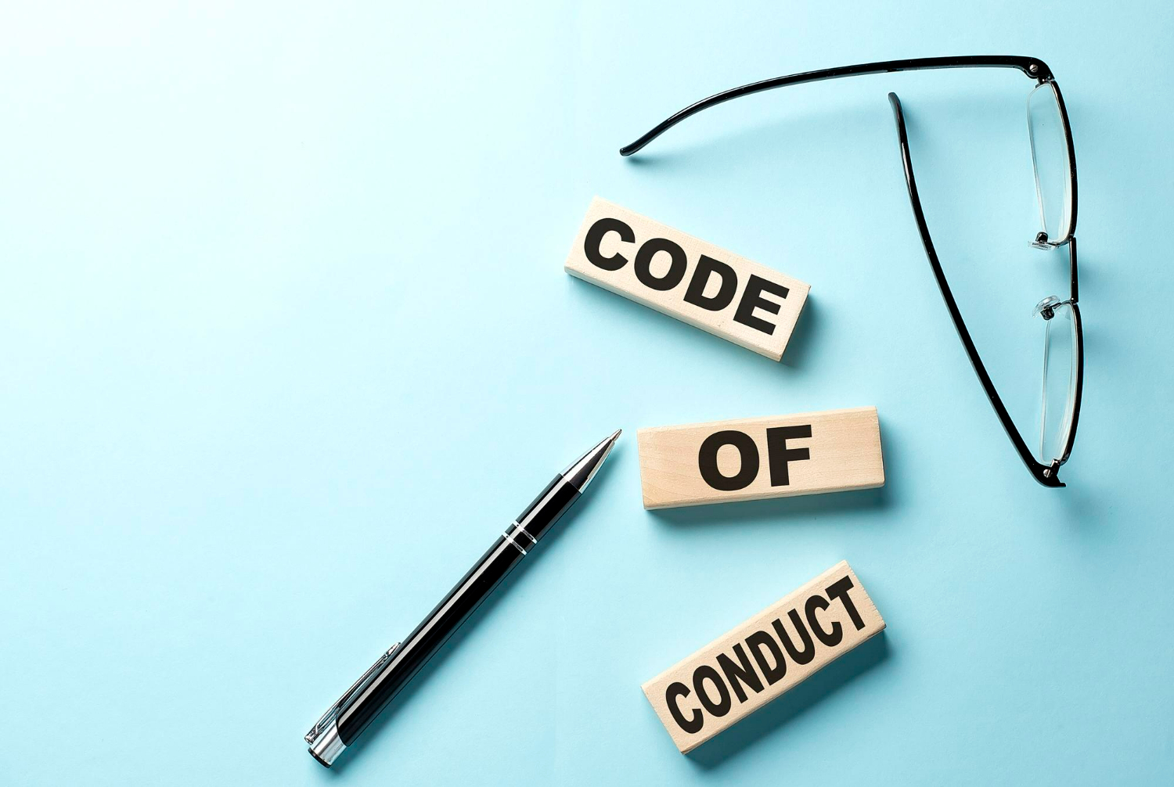

**Code of Conduct Training Workshop**

“Laws control the lesser man... Right conduct controls the greater one.”

– Mark Twain

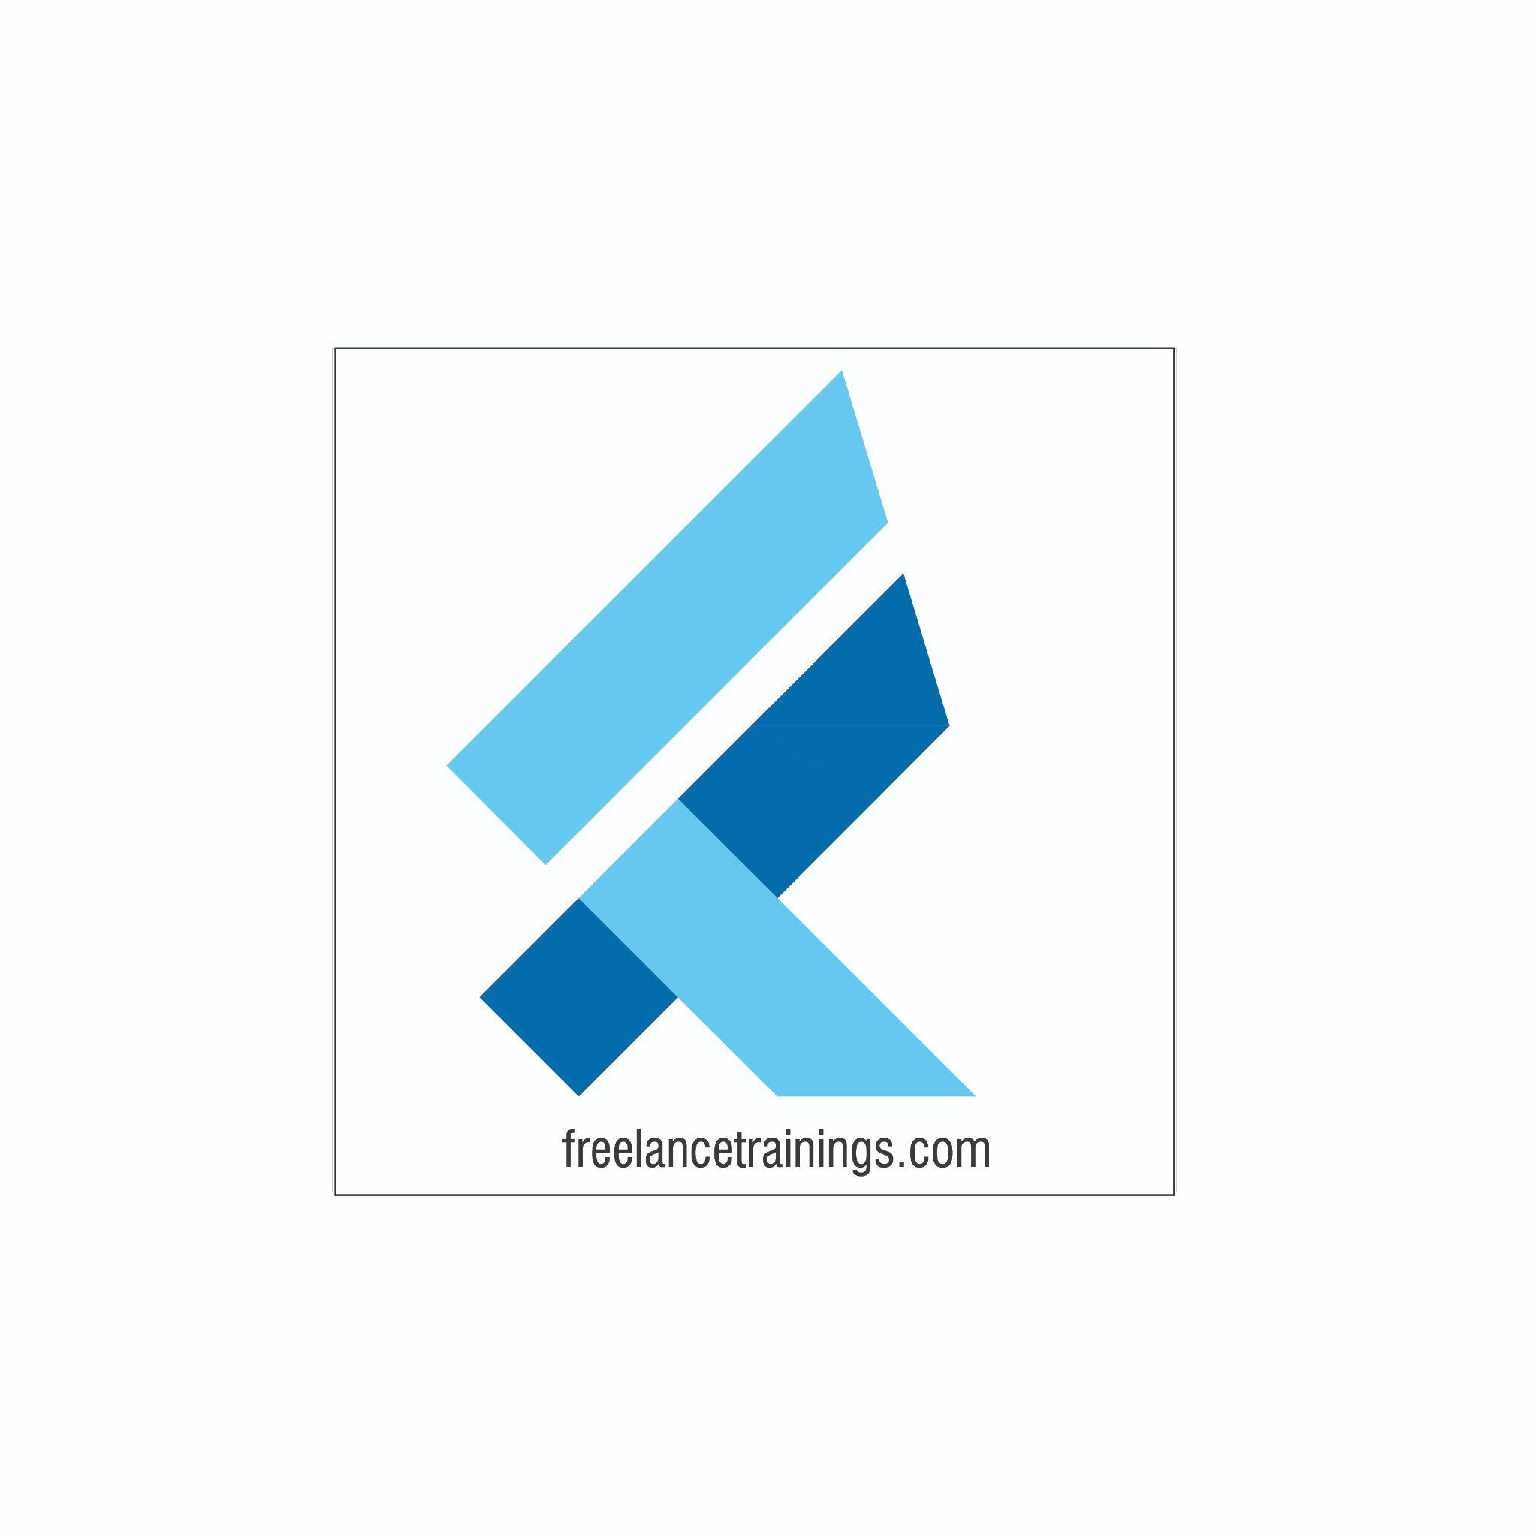

Code of Conduct Training Workshop

Duration: 3 Hours

No of Participants: 25-30 Pax

Timing: 9:30 A.M- 12:30 P.M

Target Audience

* Individual Contributors
* Supervisors
* Early Team Managers
* New Joiners
* Employees of Any department

Workshop Objectives

* Introduction and Importance of Code of Conduct
* Understanding the Code of Conduct
* Key Elements of the Code of Conduct
* Applying the Code of Conduct
* Reporting Violations and Consequences
* Q&A Session
* Conclusion and Commitment

Workshop Outline

|  |  |  |
| --- | --- | --- |
| **Sr. No.** | **Time** | **Topic** |
| 1 | 9:30- 09:45AM | **Introduction and Importance of Code of Conduct**   * Welcome and Introduction to the Workshop * Briefly explain what a Code of Conduct is * Emphasize the importance of ethical behavior and a positive work environment |
| 2 | 9:45- 10:15 AM | **Understanding the Code of Conduct**   * Define a Code of Conduct * Explain its purpose: guiding behavior, promoting ethics, and maintaining a positive workplace * Discuss how it aligns with the company's values and mission |
| 3 | 10:15- 11:00 AM | **Key Elements of the Code of Conduct**   1. **Ethical Standards and Values**    * Define ethics and values in the workplace context    * Provide examples of common ethical dilemmas    * Discuss the company's core values and how they relate to the Code of Conduct 2. **Respectful and Inclusive Behavior**    * Explain the importance of treating all individuals with respect and dignity    * Discuss the company's stance on diversity and inclusion    * Provide scenarios to Illustrate Respectful and Inclusive Behavior 3. **Conflicts of Interest**    * Define conflicts of interest and give examples    * Explain how to identify and address conflicts of interest    * Emphasize the importance of transparency and disclosure |
| 4 | 11:00- 11:15 AM | **Break** |
| 5 | 11:15- 12:00 PM | **Applying the Code of Conduct**   1. **Professional Communication**    * Discuss the significance of effective communication    * Provide guidelines for appropriate communication within the company    * Highlight the potential consequences of inappropriate communication 2. **Workplace Behavior and Attire**    * Explain the expectations for professional behavior and attire    * Discuss how personal behavior can impact the workplace environment    * Provide examples of unacceptable behavior and attire 3. **Use of Company Resources**    * Discuss responsible use of company resources, including equipment and facilities    * Address guidelines for data privacy and cybersecurity    * Highlight potential risks associated with misuse of resources |
| 6 | 12:00 -12:20 PM | **Reporting Violations and Consequences**   * Explain the process for reporting violations of the Code of Conduct * Discuss protections for whistleblowers * Outline potential consequences for violating the Code of Conduct, including disciplinary actions |
| 8 | 12:20 - 12:35 PM | **Q&A Session**   * Open the floor for questions and scenarios from participants * Facilitate a discussion around real-life scenarios and how the Code of Conduct would apply |
| 9 | 12:35 – 12:45 PM | **Conclusion and Commitment**   * Summarize key takeaways from the workshop * Emphasize participants' role in upholding the Code of Conduct * Encourage participants to commit to ethical behavior and a positive workplace environment |

*This Workshop outline is based on the industry best practices and will be customised after discussion with the client.*