

**Campus to Corporate Workshop**

“Everyone has a personal brand, by design or by default.” ― 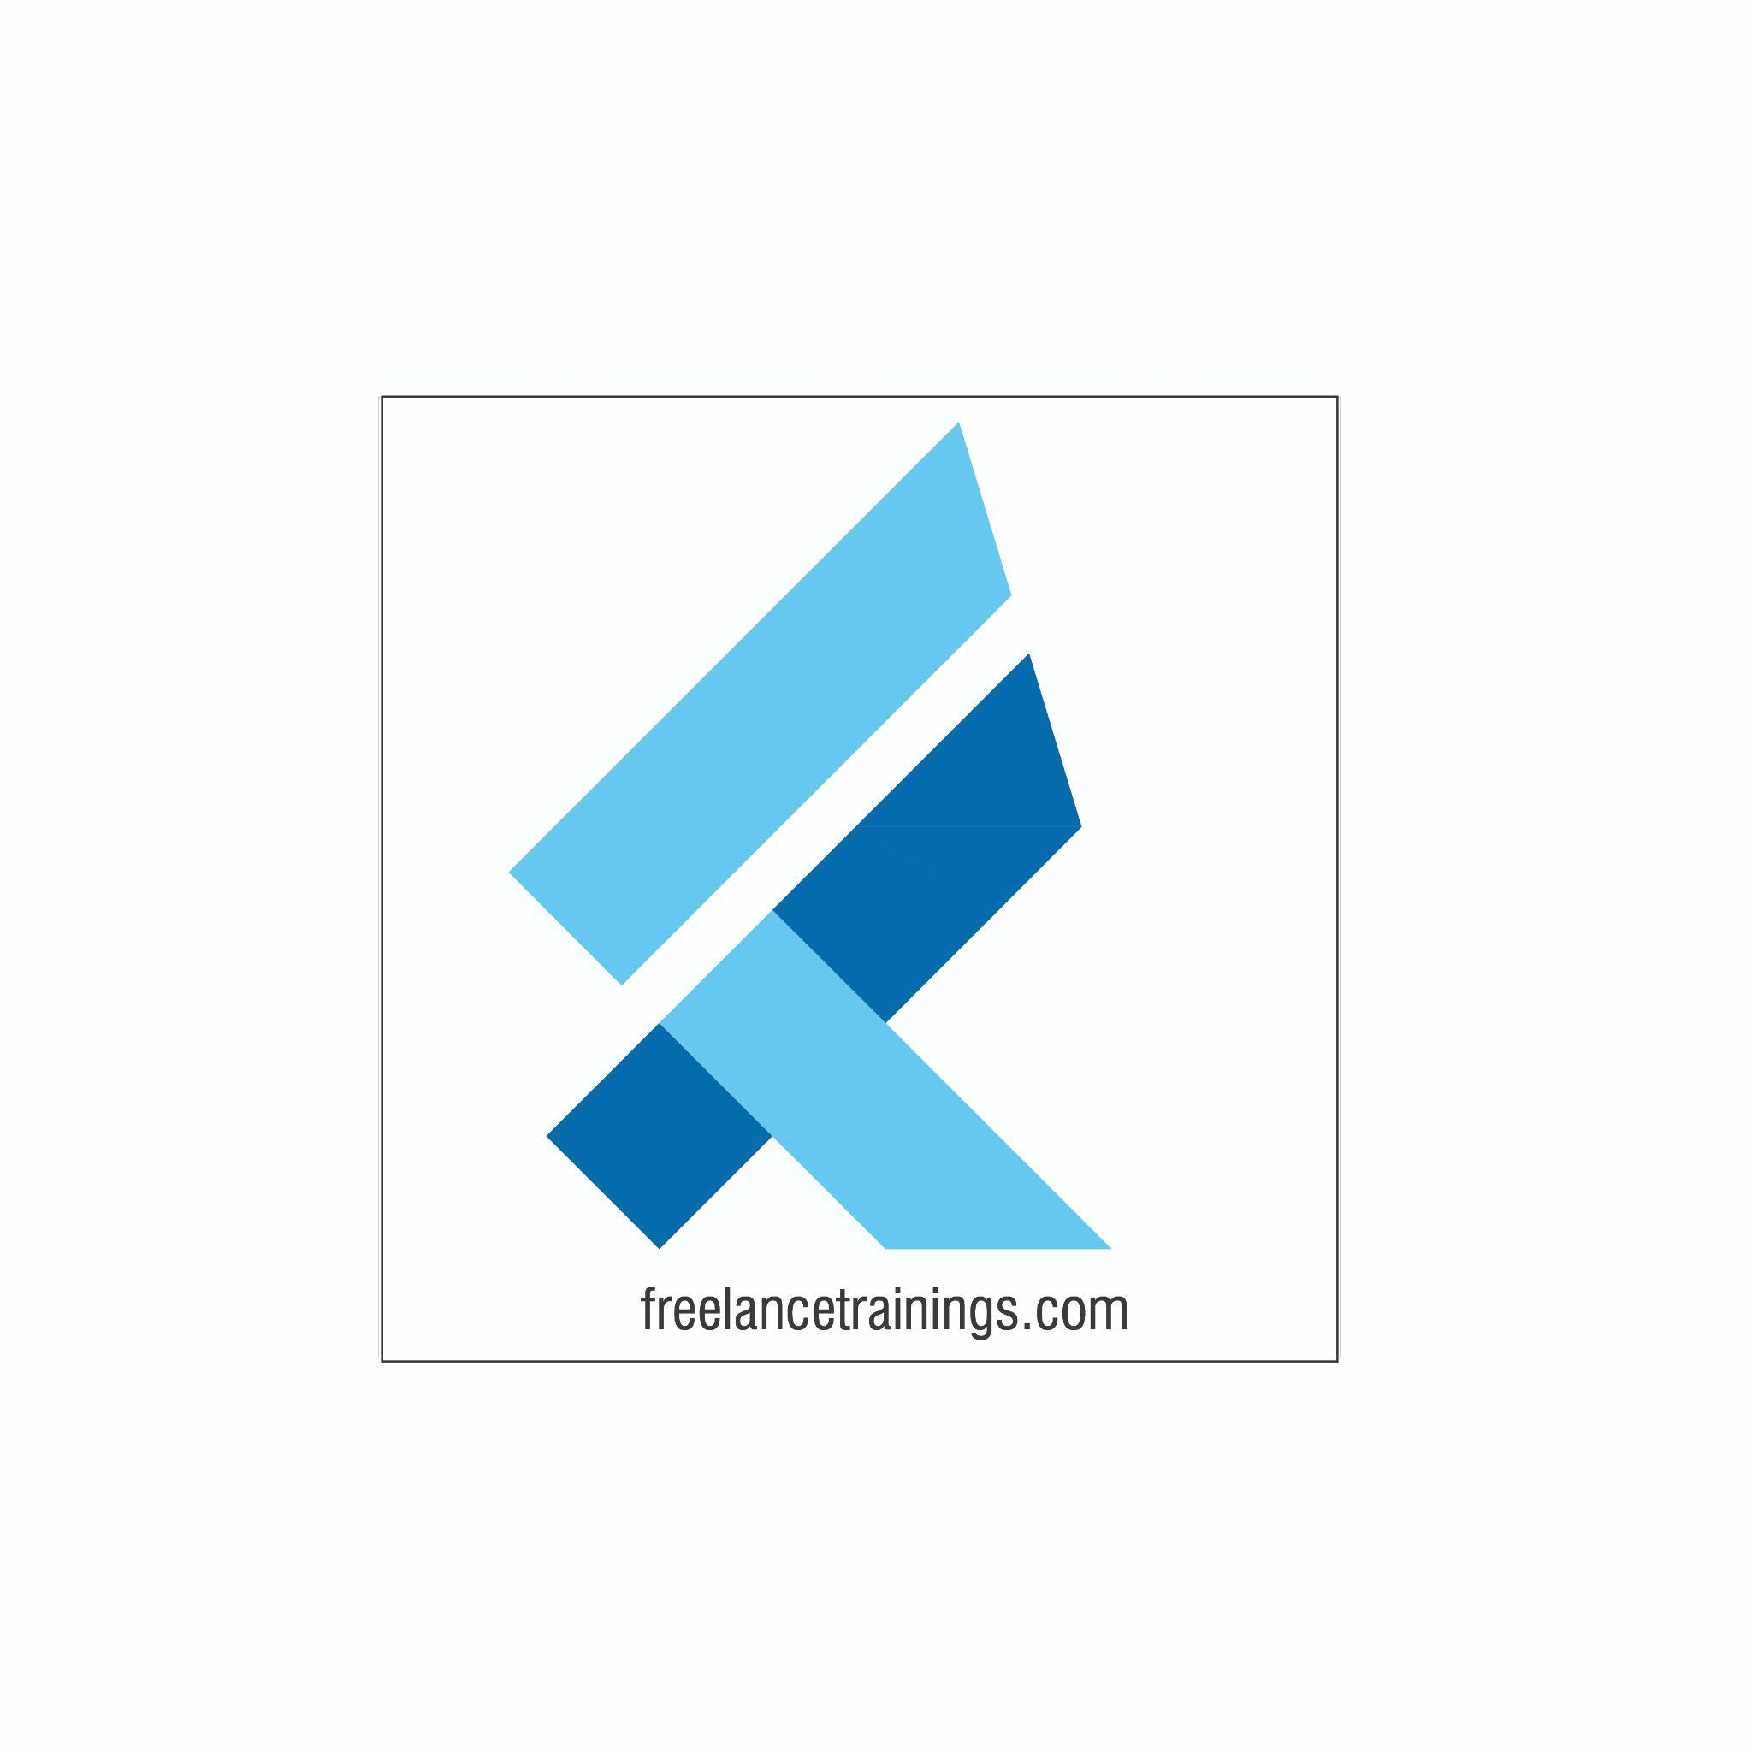Lida Citoen

Campus to Corporate Workshop

Duration: 3 Day

No of Participants: 25-30 Pax

Timing: 9:30 A.M- 5:30 P.M

Target Audience

* Final year Students
* Professors/ Lecturers/ Trainers
* Placement Officers
* New Joiners/ Freshers

Workshop Objectives

* Understanding Campus to Corporate Journey
* Workplace Communication
* Communication Process
* 4 C’s for Effective Communication
* Concept of Brand
* Building an Attitude of Ownership
* Body Language
* Resume Making Activity
* Interview & Interview Process
* LinkedIn Profile & Social Media Etiquette



Workshop Outline

|  |  |  |
| --- | --- | --- |
| **Day 1** | | |
| **Sr. No.** | **Time** | **Topic** |
| 1 | 9:30-10:15 AM | **What’s In It for Me** • Workshop Intro & Agenda • Ground Rules • Icebreaker • Facilitator Intro • Participant Intro & Expectations |
| 2 | 10:15- 10:30 AM | **Pre-Training Assessment** |
| 3 | 10:30- 11:00 AM | **Campus to Corporate Journey**  • Understanding Campus to Corporate Journey |
| 4 | 11:00 -11:15 AM | **First Tea Break** |
| 5 | 11:15 -12:30 PM | **Understanding Workplace Communication •** Understanding workplace communication? • Role of Communication- Individual • Role of Communication-Organisation • Benefits of workplace communication |
| 6 | 12:30 -1:15 PM | **Communication Process •** Understanding Communication process • Steps involved in the process • Role of each party • Myths about workplace communication |
| 7 | 1:15 - 2:00 PM | **Lunch Break** |
| 8 | 2:00 - 2:15 PM | **Energiser** |
| 9 | 2:15- 3:00 PM | **Cornerstone of Effective communication •** Communicate Impactfully-5W’s & 1 H • Why & What to communicate • Who, Where, When to communicate • How to draft a communication |
| 10 | 3:00-4:00 PM | **4 C’s for Effective Communication •** Clear  • Concise • Concrete-Specific • Customised |
| 11 | 4:00 - 4:15 AM | **Second Tea Break** |
| 12 | 4:15- 4:30 PM | **Types of Communication**  **•** Mehrabian Model • Verbal • Visual • Non-Verbal-Communication |
| 13 | 4:30- 4:45 PM | **Recap** |
| 14 | 4:45- 5:00 PM | **Post Training Assessment** |
| 15 | 5:00- 5:30 PM | **Closing** • Q& A (If any) • Closing Video (If any) |
| **Day 2** | | |
| 1 | 9:30-10:15 AM | **Recap Day-1** |
| 2 | 10:15- 10:30 AM | **Pre-Training Assessment** |
| 3 | 10:30- 11:15 AM | **Concept of Brand** • Brand & its Importance  • Qualities of Brand (Powerful, Consistent, Visible, Valuable) • Individuals as personal brands • Building a personal brand- (Knowledge, Skills & Attitude) |
| 4 | 11:15 -11:30 AM | **First Tea Break** |
| 5 | 11:30 - 12:30 PM | **Building an Attitude of Ownership** • Understanding Ownership • Developing a Proactive Approach-Circle of Control • Building a solution Centric • Walking the Extra Mile- How to Avoid Blame Game |
| 6 | 12:30 - 1:15 PM | **Nonverbal Communication** • Mehrabian Model- (Visual, Vocal & Verbal) • Components of Visual • Body Language • Attire • Hygiene & Grooming |
| 7 | 1:15 - 2:00 PM | **Lunch Break** |
| 8 | 2:00 - 2:15 PM | **Energizer** |
| 9 | 2:15 - 3:15 PM | **Body Language (As per Indian Corporate Standard)**  • Introduction • Greetings  • Handshake • Business Card Etiquette • Eye Contact • Personal Space |
| 10 | 3:15 - 4:00 PM | **Looks Matter** • Formal Dressing Males & Females • Casual Dressing • Accessories for Males & Females • Belts & Footwear • Some commonly observed rules |
| 11 | 4:00- 4:15 PM | **Second Tea Break** |
| 12 | 4:15- 4:45 PM | **Watch the Odour** • Knowing the body Odours • Bad Breath • Doe Vs. Perfume • Some commonly observed rules |
|  | 4:45- 5:00 PM | **Recap** |
| 13 | 5:00- 5:15 PM | **Post Training Assessment** |
| 14 | 5:15- 5:30 PM | **Closing** • Q& A (If any) • Closing Video (If any) |
| **Day 3** | | |
| 1 | 9:30-9:45 AM | **Recap Day-2** |
| 2 | 9:45- 10:00 AM | **Pre-Training Assessment** |
| 3 | 10:00- 11:15 AM | **Understanding Resume**   * What is Resume? * Key Components of a Resume * Difference between Resume, CV Or Biodata |
| 4 | 11:15 -11:30 AM | **First Tea Break** |
| 5 | 11:30 -12:00 PM | **Resume Making Activity**   * Types of Resume & Layouts * Important Part of Resume & Examples * Resume Writing Mistakes * How to review Resume |
| 6 | 12:00 - 12:30 PM | **Job Descriptions**   * Understanding Job Descriptions * Key Components of Job Description (JD) * Why Customising Resumes to JD * How to Customise Resumes as per JD |
| 7 | 12:30 - 1:15 PM | **Cover Letter & Group Discussion**   * Understanding Cover Letter * Key Components of Cover Letter * Tips for effective Cover Letters * What is Group Discussion? * Importance of Group Discussions * Key Features of Group Discussion * Tips for Group Discussion |
| 8 | 1:15 – 2:00 PM | **Lunch Break** |
| 9 | 2:00 – 3:15 PM | **Interview & Interview Process**   * What is Interviewing Skills? * Common Challenges Faced * Types of Interviews * Benefits of Interview * Skills that Employers look for * Understanding Interview Process? * Pre-Interview Preparation & Benefits * STAR Model Technique * Tips for interview |
| 10 | 3:10 – 4:00 PM | **Interview Practice** |
| 11 | 4:00 – 4:15 PM | **Second Tea Break** |
| 12 | 4:15 – 4:45 PM | **LinkedIn Profile & Social Media Etiquette**   * Understanding LinkedIn * LinkedIn Profile * How to make LinkedIn Profile * Social Media Etiquettes for Freshers |
| 13 | 4:45 - 5:00 PM | **Recap** |
| 14 | 5:00- 5:15 PM | **Post Training Assessment** |
| 15 | 5:15- 5:30 PM | **Closing**   * Feedback forms * Q&A (If any) * Closing Video (If any) * Group Photo |

*This Workshop outline is based on the industry best practices and will be customised after discussion with the client.*