

**Business Etiquette Workshop**

"You too are a brand, whether you know it or not, whether you like it or not" -Marc Ecko

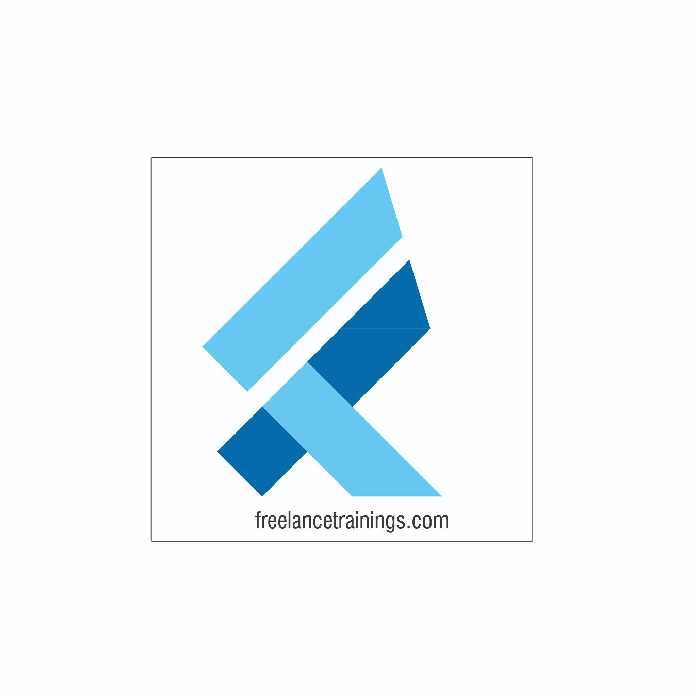

Business Etiquette Workshop

Duration: 1 Day

No of Participants: 25-30 Pax

Timing: 9:30 A.M- 5:30 P.M

Target Audience

* Individual Contributors
* Supervisors
* Early Team Managers
* Employees of any department

Workshop Objectives

* Concept of Brand
* Building an Attitude of Ownership
* Nonverbal Communication
* Body Language
* Looks Matter
* Watch the Odour



Workshop Outline

|  |  |  |
| --- | --- | --- |
| **Sr. No.** | **Time** | **Topic** |
| 1 | 9:30-10:15 AM | **What’s In It for Me** • Workshop Intro & Agenda • Ground Rules • Icebreaker • Facilitator Intro • Participant Intro & Expectations |
| 2 | 10:15- 10:30 AM | **Pre-Training Assessment** |
| 3 | 10:30- 11:15 AM | **Concept of Brand** • Brand & its Importance  • Qualities of Brand (Powerful, Consistent, Visible, Valuable) • Individuals as personal brands • Building a personal brand- (Knowledge, Skills & Attitude) |
| 4 | 11:15 -11:30 AM | **First Tea Break** |
| 5 | 11:30 - 12:30 PM | **Building an Attitude of Ownership** • Understanding Ownership • Developing a Proactive Approach-Circle of Control • Building a solution Centric • Walking the Extra Mile- How to Avoid Blame Game |
| 6 | 12:30 - 1:15 PM | **Nonverbal Communication** • Mehrabian Model- (Visual, Vocal & Verbal) • Components of Visual • Body Language • Attire • Hygiene & Grooming |
| 7 | 1:15 - 2:00 PM | **Lunch Break** |
| 8 | 2:00 - 2:15 PM | **Energizer** |
| 9 | 2:15 - 3:15 PM | **Body Language (As per Indian Corporate Standard)**  • Introduction • Greetings  • Handshake • Business Card Etiquette • Eye Contact • Personal Space |
| 10 | 3:15 - 4:00 PM | **Looks Matter** • Formal Dressing Males & Females • Casual Dressing • Accessories for Males & Females • Belts & Footwear • Some commonly observed rules |
| 11 | 4:00- 4:15 PM | **Second Tea Break** |
| 12 | 4:15- 4:45 PM | **Watch the Odour** • Knowing the body Odours • Bad Breath • Doe Vs. Perfume • Some commonly observed rules |
| 13 | 4:45 - 5:00 PM | **Post Training Assessment** |
| 14 | 5:00 -5:30 PM | **Closing** • Feedback forms • Q& A (If any) • Closing Video (If any) • Group Photo |

*This Workshop outline is based on the industry best practices and will be customised after discussion with the client.