

Business Etiquette Workshop
"You too are a brand, whether you know it or not, whether you like it or not" -Marc Ecko

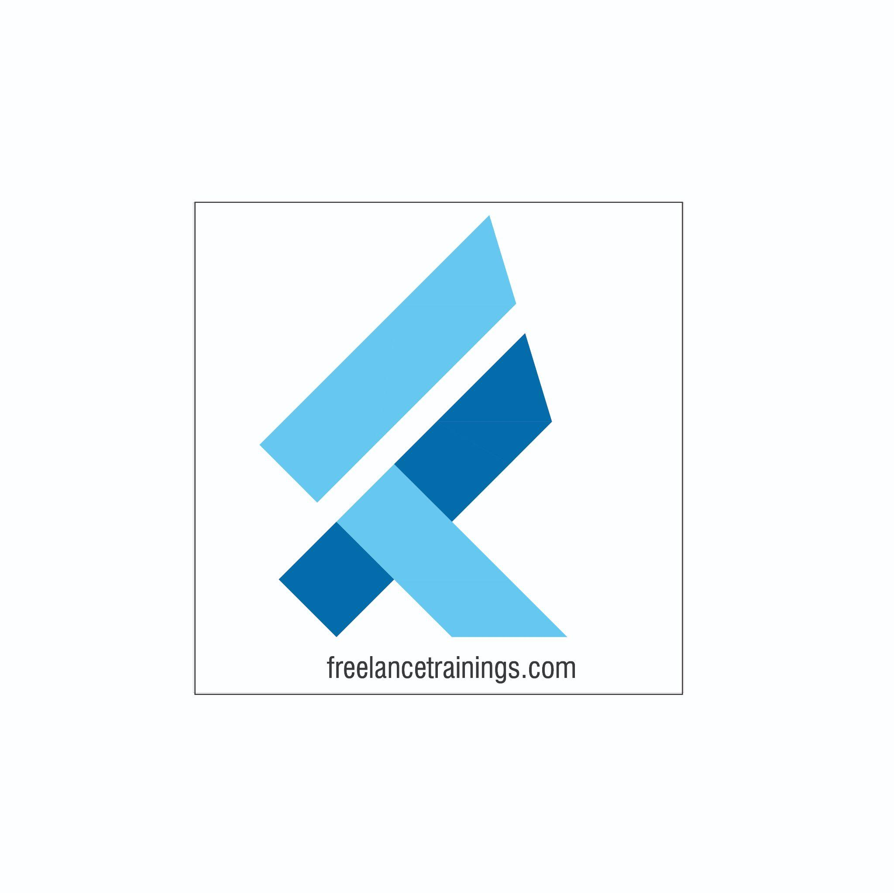

Business Etiquette Workshop
Duration: 2 Day
No of Participants: 25-30 Pax
Timing: 9:30 A.M- 5:30 P.M


Target Audience
- Individual Contributors
- Supervisors
- Early Team Managers
- Employees of any department

Workshop Objectives

- Concept of Brand
- Building an Attitude of Ownership
- Nonverbal Communication
- Body Language
- Looks Matter
- Watch the Odour
- Email Etiquette
- Telephone & Meeting Etiquettes
- Social Etiquettes


Workshop Outline

Day 1

Sr. No. | Time | Topic
1 | 9:30-10:15 AM | What’s In It for Me  • Workshop Intro & Agenda  • Ground Rules  • Facilitator Intro  • Icebreaker + Participant Intro & Expectations
2 | 10:15- 10:30 AM | Pre-Training Assessment
3 | 10:30- 11:15 AM | Concept of Brand  • Brand & its Importance  • Qualities of Brand (Powerful, Consistent, Visible, Valuable)  • Individuals as personal brands  • Building a personal brand- (Knowledge, Skills & Attitude)
4 | 11:15 -11:30 AM | First Tea Break
5 | 11:30 - 12:30 PM | Building an Attitude of Ownership  • Understanding Ownership  • Developing a Proactive approach-Circle of Control  • Building a solution Centric  • Avoid Blame Game- Walking the Extra Mile
6 | 12:30 - 1:15 PM | Nonverbal Communication  • Mehrabian Model- (Visual, Vocal & Verbal)  • Components of Visual  • Body Language  • Attire  • Hygiene & Grooming
7 | 1:15 - 2:00 PM | Lunch Break
8 | 2:00 - 2:15 PM | Energizer
9 | 2:15 - 3:15 PM | Body Language (As per Indian Corporate Standard)  • Introduction  • Greetings  • Handshake  • Business Card Etiquette  • Eye Contact  • Personal Space
10 | 3:15 - 4:00 PM | Looks Matter  • Formal Dressing Males & Females  • Casual Dressing  • Accessories for Males & Females  • Belts & Footwear  • Some commonly observed rules
11 | 4:00- 4:15 PM | Second Tea Break
12 | 4:15- 4:45 PM | Watch the Odor  • Knowing the body Odors  • Bad Breath  • Deo Vs Perfume  • Some commonly observed rules
13 | 4:45 - 5:00 PM | Recap of Day 1
14 | 5:00 -5:30 PM | Closing  • Q& A  • Closing Video  • Homework for day 2 (Optional)
Day 2
Sr. No. | Time | Topic
1 | 9:30-10:00 AM | What’s In It for Me  • Recap of Day 1-Activity  • Agenda
2 | 10:00- 11:15 AM | Vocal Communication  • Components of Voice  • Choosing the right tone  • Pitch & Pace of Voice  • Listening with empathy
3 | 11:15 -11:30 AM | First Tea Break
4 | 11:30 - 1:00 PM | Dining Etiquette  • Napkin Etiquettes  • Cutlery Etiquettes  • Sitting arrangement  • Drinking Soup  • American Vs Continental
5 | 1:00 - 1:45 PM | Lunch Break
6 | 1:45 - 2:00 PM | Energizer
7 | 2:00 - 3:30 PM | Email Etiquette  • Email Addressing  • Subject Line  • Salutation  • Email Body, Signature & Attachment  • Best Practice
8 | 3:30- 4:00 PM | Telephone & Meeting Etiquettes  • Mobile Phone  • Conference call  • Web Calls & meetings  • Physical Meeting’s
9 | 4:00- 4:15 PM | Second Tea Break
10 | 4:15- 4:30 PM | Social Etiquettes  • Punctuality  • Courtesy  • Gifting & Tipping
11 | 4:30 - 4:45 PM | Post Training Assessment
12 | 4:45 -5:30 PM | Closing  • Feedback forms  • Q& A (If any)  • Closing Video (If any)  • Group Photo

*This Workshop outline is based on the industry best practices and will be customised after discussion with the client.

