

Onboarding Workshop
" While you can think in terms of efficiency in dealing with time ,a principle -centered person thinks in terms of effectiveness in dealing with people ”.
– Stephen R Covey
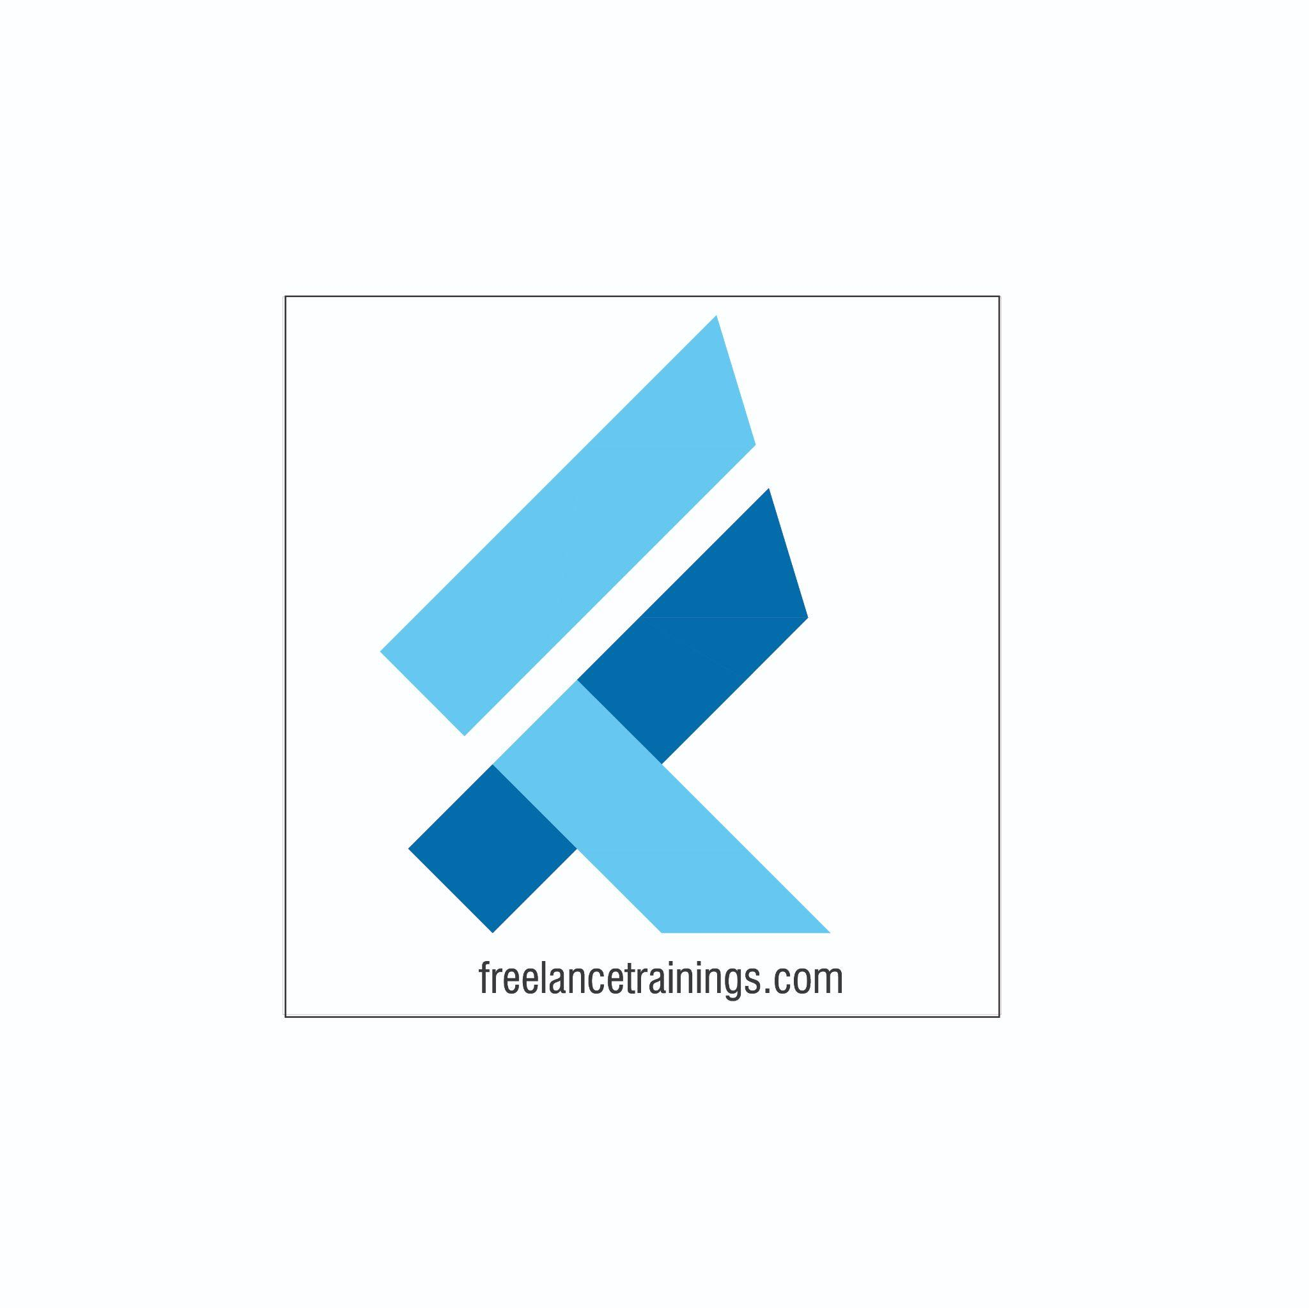

Onboarding Workshop-Soft Skills
Duration: 1 Day
No of Participants: 25-30 Pax
Timing: 9:30 A.M- 5:30 P.M


Target Audience
- Individual Contributors
- Supervisors
- New Joiners
- Employees of any department

Workshop Objectives

- Understanding Personal Effectiveness
- Building an attitude of Ownership & Accountability
- Impactful Communication
- Building Fool Proof Communication
- Goal Setting
- Being a Team Player- Interpersonal Skills



Workshop Outline

Sr. No. | Time | Topic
1 | 9:30 – 10:15 AM | What’s In It for Me  - Workshop Intro & Agenda  - Ground Rules  - Icebreaker  - Facilitator Intro  - Participant Intro & Expectations
2 | 10:15 -10:30 AM | Pre-Training Assessment
3 | 10:30 -11:15 AM | Trainer is free to customise the First Module- Since this will be a part of Onboarding Training where the client would have already covered few topics (Usually company, policies, HR & other on previous days. So the trainer can start it afresh from Personal effectiveness/ Build a link with previous days content.  Understanding Personal Effectiveness  - Personal Effectiveness  - Benefits of Personal Effectiveness (Self + Organisation)  - Building Personal Excellence (ASK)- Attitude, Skills, Knowledge)
4 | 11:15- 11:30 AM | First Tea Break
5 | 11:30- 12:15 PM | Building an attitude of Ownership & Accountability  • Understanding Ownership  • Developing a Proactive approach-Circle of Control  • Building a solution Centric  • Avoid Blame Game- Walking the Extra Mile
6 | 12:15 -1:15 PM | Impactful Communication  - Types of Communication (Assertive, Aggressive & Passive)  - Pros & Cons of each Type  - Developing assertive style of communication  - Building Empathetic communication
7 | 1:15 - 2:00 PM | Lunch Break
8 | 2:00 - 2:15 PM | Energiser
9 | 2:15 - 3:00 PM | Building Fool Proof Communication  • LADR Model of Communication  • Listening Actively  • Asking Questions (Open Vs Close ended)  • Reconfirm
10 | 3:00 – 3: 45 PM | Goal Setting  - Benefits of Setting Goals  - Goal setting Mistakes  - Goal Setting exercise  - Making your Goals SMART (Specific, Measurable, Achievable, Realistic and Time Bound
11 | 3:45 - 4:00 PM | Second Tea Break
12 | 4:00- 4:30 PM | Being a Team Player- Interpersonal Effectiveness  - Understanding Interpersonal Effectiveness  - Importance of the same- Individual & Organisation  - Interpersonal Communication- Some Misconceptions  - Ways to enhance Interpersonal skills
13 | 4:30 - 4:45 PM | Recap of Day
14 | 4:45 - 5:00 PM | Post Training Assessment
15 | 5:00 -5:30 PM | Closing  • Feedback forms  • Q& A (If any)  • Closing Video (If any)  • Group Photo

*This is an indicative outline based on Industry best practices and the same can be customised by the trainer as per the client’s need and discussion.

