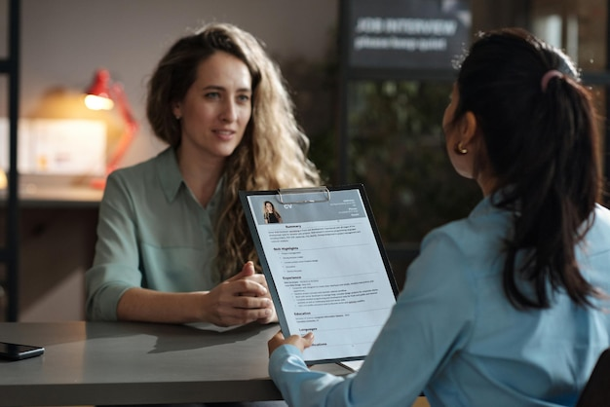

Resume Writing & Interview Skills Workshop
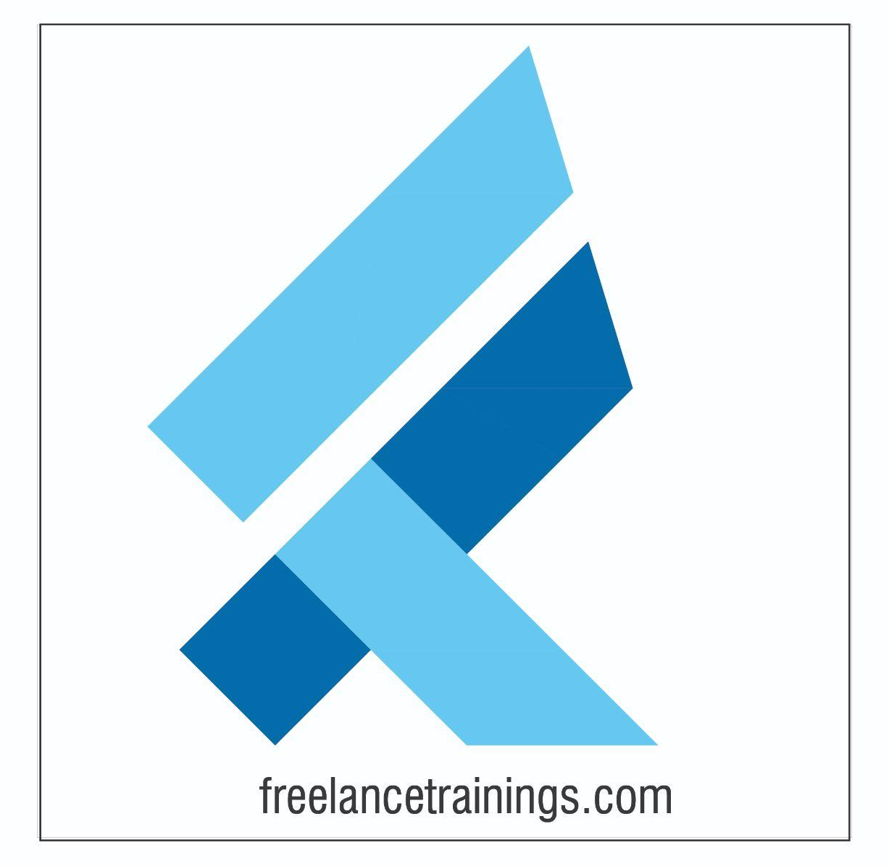
“There are no limits that you can accomplish except the limits that you place on your own thinking.” ― Brian Tracy

Resume Writing & Interview Skills Workshop
Duration: 1 Day
No of Participants: 25-30 Pax
Timing: 9:30 A.M- 5:30 P.M


Target Audience
- Final year Students
- Professors/ Lecturers/ Trainers
- Placement Officers
- New Joiners/ Freshers

Workshop Objectives
- Understanding Resume
- Resume Making
- Job Description & Their Importance
- Importance of cover letter & group discussion
- Group Discussion Practice
- Interview Skills
- Interview Process
- Creating LinkedIn Profile
- Social Media Etiquette
- Tips for Interviews


Workshop Outline

Day 1
Sr. No. | Time | Topic
1 | 9:30-10:15 AM | What’s In It for Me  • Workshop Intro & Agenda  • Ground Rules  • Icebreaker  • Facilitator Intro  • Participant Intro & Expectations
2 | 10:15- 10:30 AM | Pre-Training Assessment
3 | 10:30- 11:15 AM | Understanding Resume  - What is Resume?  - Key Components of a Resume  - Difference between Resume, CV Or Biodata
4 | 11:15 -11:30 AM | First Tea Break
5 | 11:30 -12:00 PM | Resume Making Activity  - Types of Resume & Layouts  - Important Part of Resume & Examples  - Resume Writing Mistakes  - How to review Resume
6 | 12:00 - 12:30 PM | Job Descriptions  - Understanding Job Descriptions  - Key Components of Job Description (JD)  - Why Customising Resumes to JD  - How to Customise Resumes as per JD
7 | 12:30 - 1:15 PM | Cover Letter & Group Discussion  - Understanding Cover Letter  - Key Components of Cover Letter  - Tips for effective Cover Letters  - What is Group Discussion?  - Importance of Group Discussions  - Key Features of Group Discussion  - Tips for Group Discussion
8 | 1:15 – 2:00 PM | Lunch Break
9 | 2:00 – 2:15 PM | Group Discussion Activity
10 | 2:15 – 3:15 PM | Interview & Interview Process  - What is Interviewing Skills?  - Common Challenges Faced  - Types of Interviews  - Benefits of Interview  - Skills that Employers look for  - Understanding Interview Process?  - Pre-Interview Preparation & Benefits  - STAR Model Technique  - Tips for interview
11 | 3:10 – 4:00 PM | Interview Practice
12 | 4:00 – 4:15 PM | Second Tea Break
13 | 4:15 – 4:45 PM | LinkedIn Profile & Social Media Etiquette  - Understanding LinkedIn  - LinkedIn Profile  - How to make LinkedIn Profile  - Social Media Etiquettes for Freshers
14 | 4:45 - 5:00 PM | Recap
15 | 5:00- 5:15 PM | Post Training Assessment
16 | 5:15- 5:30 PM | Closing  - Feedback forms  - Q&A (If any)  - Closing Video (If any)  - Group Photo

*This Workshop outline is based on the industry best practices and will be customised after discussion with the client.*

