

Workplace Communication Workshop
The greatest problem in communication is the illusion that it has been accomplished. – George Bernard Shaw

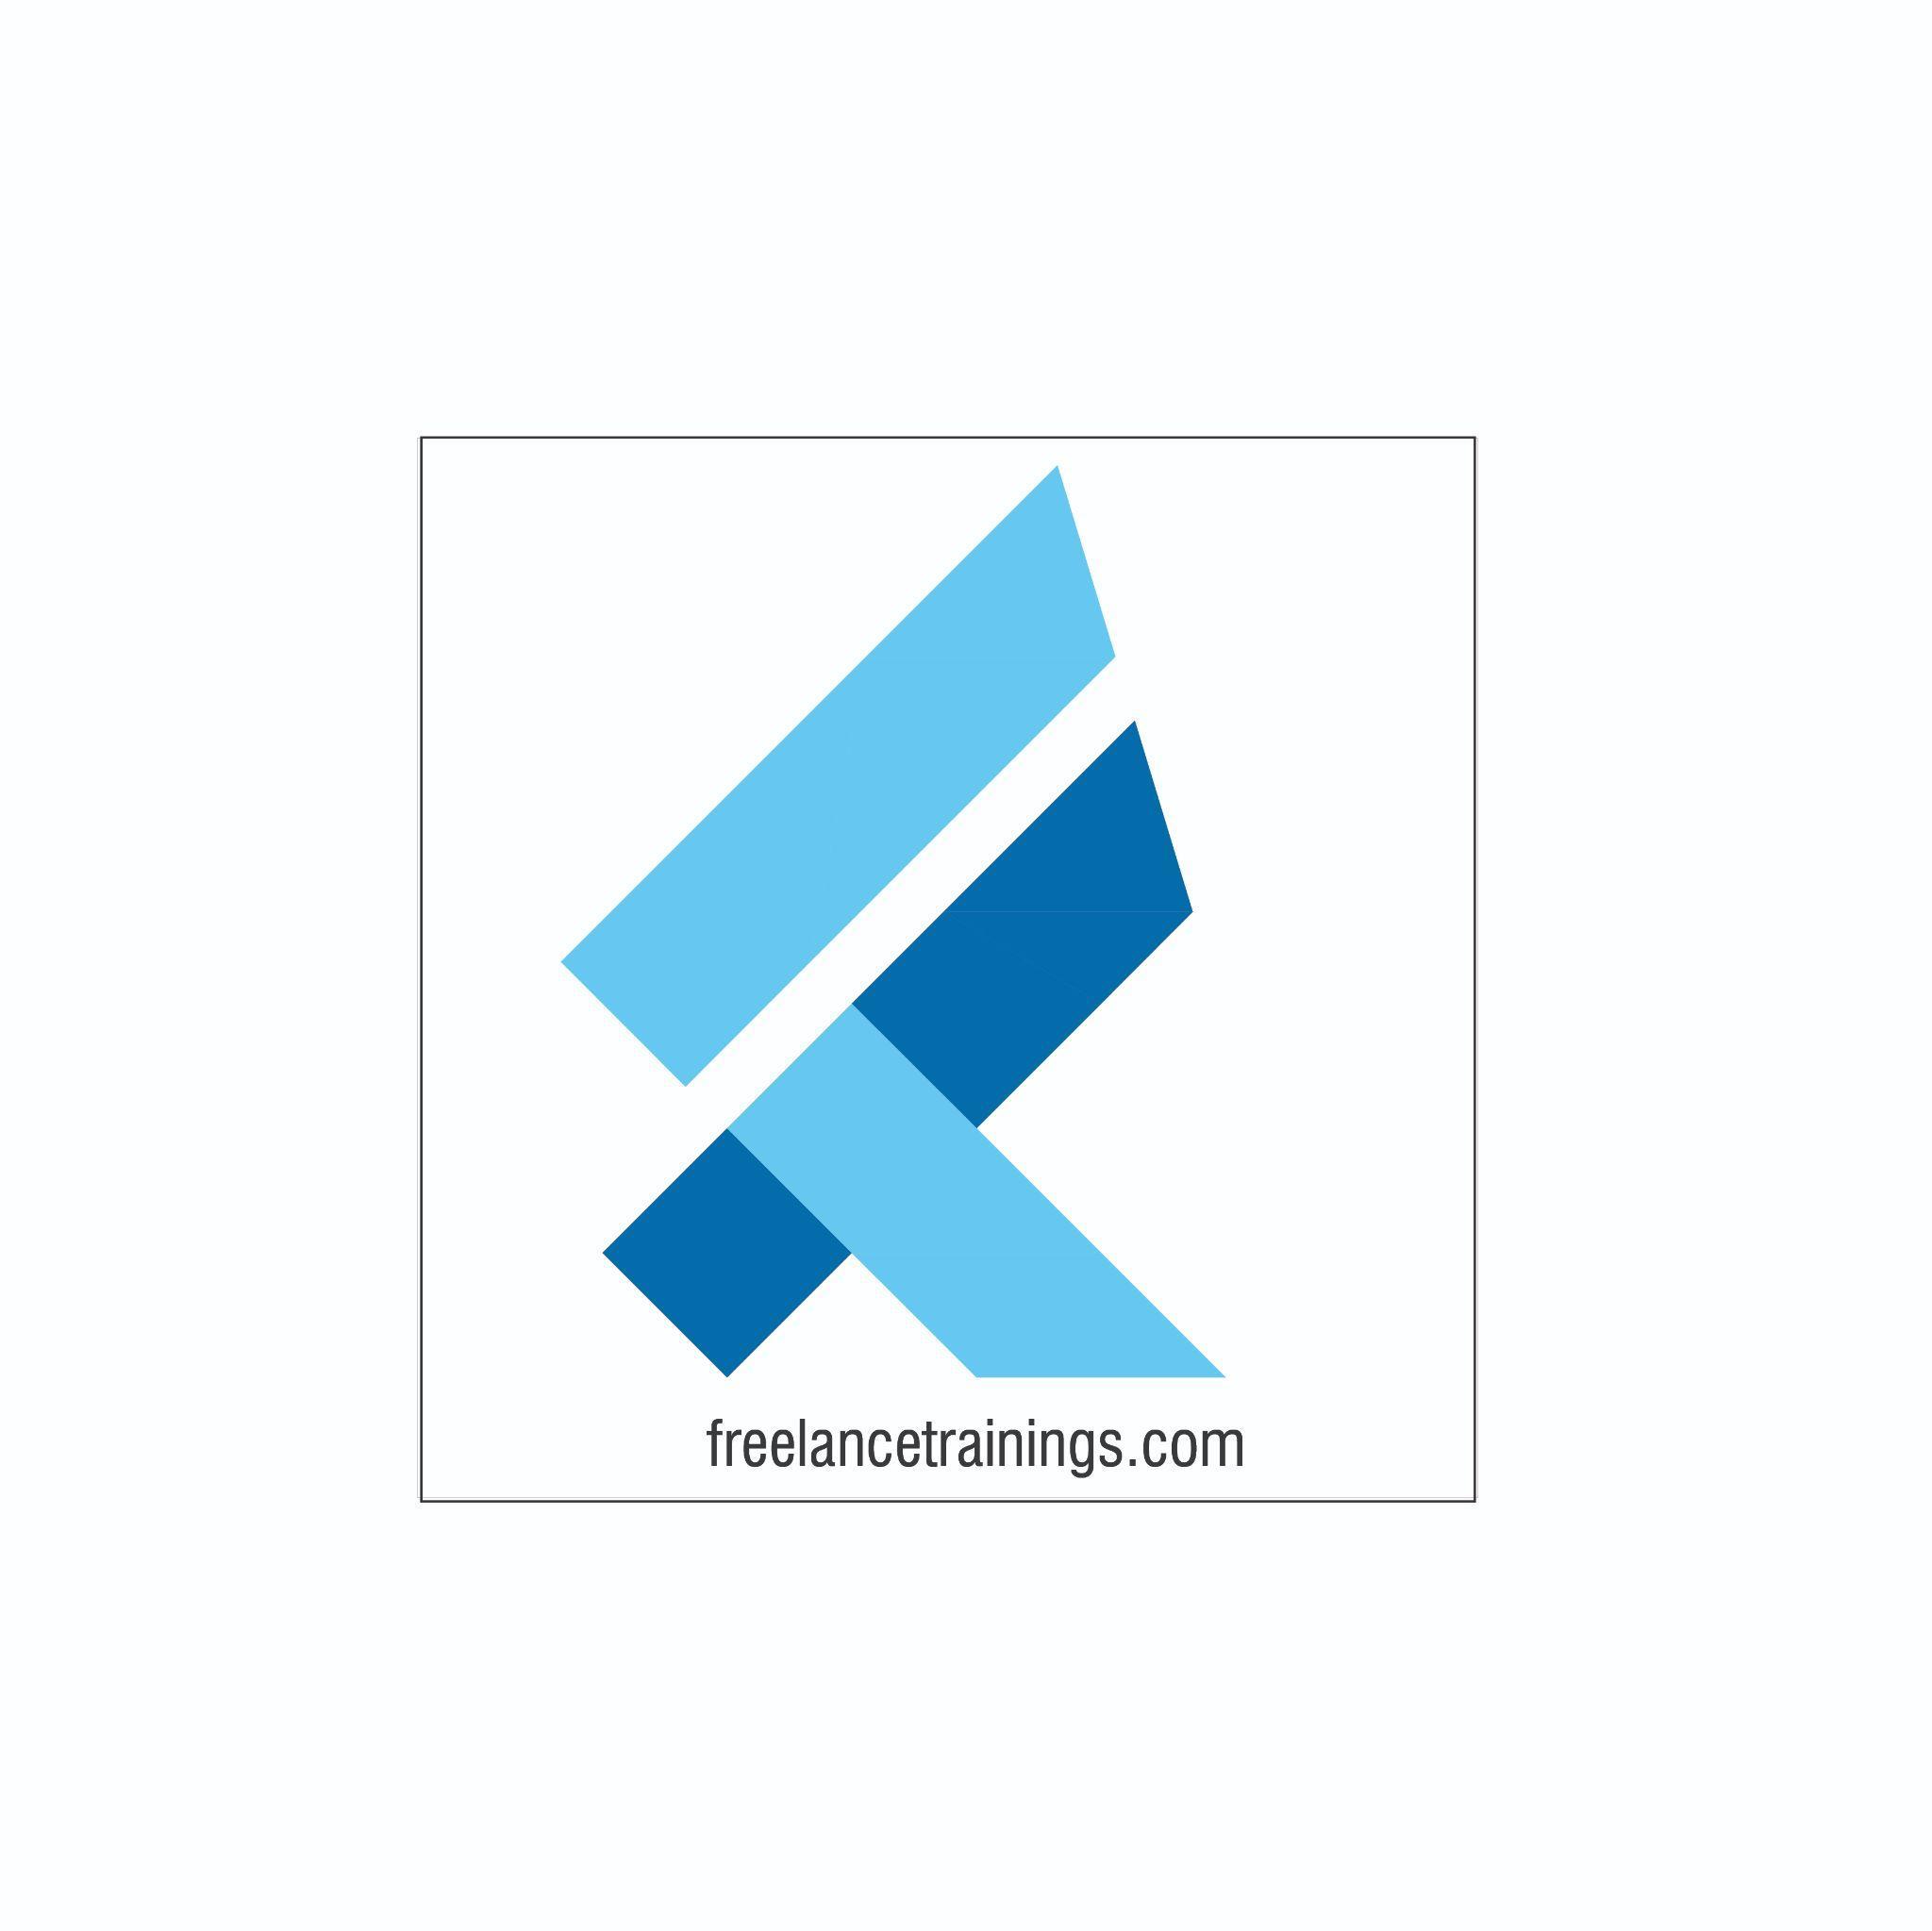

Workplace Communication Workshop
Duration: 2 Days
No of Participants: 25-30 Pax
Timing: 9:30 A.M- 5:30 P.M


Target Audience
- Individual Contributors
- Supervisors
- Early Team Managers
- Employees of any department

Workshop Objectives

- Understanding workplace communication
- Myths of workplace communication
- Communication Process
- Cornerstones of effective communication(5W & 1 H)
- LADR Model- Listening, Asking Question, Reconfirm
- 4 C's of effective communication
- Mehrabian Model-Verbal, Vocal & Visual
- Non-verbal communication & Its Components
- Assertive, Aggressive & Empathetic communication

- Communication Barriers

Workshop Outline

Day 1
Sr. No. | Time | Topic
1 | 9:30-10:15 AM | What’s In It for Me  • Workshop Intro & Agenda  • Ground Rules  • Icebreaker  • Facilitator Intro  • Participant Intro & Expectations
2 | 10:15- 10:30 AM | Pre Training Assessment
3 | 10:30- 11:00 AM | Understanding Workplace Communication  • Understanding workplace communication?  • Role of Communication- Individual  • Role of Communication-Organisation  • Benefits of workplace communication
4 | 11:00 -11:15 AM | First Tea Break
5 | 11:15 -12:30 PM | Communication Process  • Understanding Communication process  • Steps involved in the process  • Role of each party  • Myths about workplace communication
6 | 12:30 -1:15 PM | Cornerstone of Effective communication  • Communicate Impactfully-5W’s & 1 H  • Why & What to communicate  • Who, Where, When to communicate  • How to draft a communication
7 | 1:15 - 2:00 PM | Lunch Break
8 | 2:00 - 2:15 PM | Energiser
9 | 2:15- 3:00 PM | 4 C’s for Effective Communication  • Clear  • Concise  • Concrete-Specific  • Customised
10 | 3:00-4:00 PM | Making Communication Fool proof  • Applying LADR Model  • Listening Actively  • Asking Questions  • Doubts Clarify  • Reconfirm
11 | 4:00 - 4:15 AM | Second Tea Break
12 | 4:15- 4:45 PM | Forms of Communication  • Mehrabian Model  • Verbal  • Visual  • Non Verbal-Communication
13 | 4:45- 5:00 PM | Recap of Day 1
14 | 5:00 - 5:30 PM | Closing  • Q& A  • Closing Video  • Homework for day 2 (Optional)
Day 2
Sr. No. | Time | Topic
1 | 9:30-10:00 AM | What’s In It for Me  • Recap of Day 1-Activity  • Agenda
2 | 10:00- 11:15 AM | Verbal Communication  • Importance of Verbal Communication  • Verbal Communication Forms  • Modes of Verbal Communication (Vocal, Visual, Written)
3 | 11:15 -11:30 AM | First Tea Break
4 | 11:30 - 12:15 PM | Vocal Communication  • Volume  • Pace  • Pause  • Intonation  • Pronunciation
5 | 12:15 - 1:00 PM | Visual & Written Communication  • Visual Communication & Types  • Written communication Types  • Transactional  • Informational  • Instructional  • Tips for Written communication
6 | 1:00 - 1:45 PM | Lunch Break
7 | 1:45 - 2:00 PM | Energiser
8 | 2:00 - 2:45 PM | Non Verbal Communication  • Components of Non Verbal Communication  • Importance of Nonverbal  • Body Language  • Gestures & Posture  • Eye Contact  • Facial Expressions
9 | 2:45 - 3:30 PM | Types of Communication  • Aggressive  • Passive  • Assertive  • Empathetic
10 | 3:30 - 4:15 PM | Barriers in Communication  • Understanding Communication Barriers  • Linguistic barriers  • Psychological Barriers  • Emotional Barriers  • Physical Barriers  • Cultural Barriers  • Organisational Structure Barriers  • Tips to overcome the barriers
11 | 4:15- 4:30 PM | Second Tea Break
12 | 4:30 - 4:45 PM | Post Training Assessment
13 | 4:45 - 5:00 PM | Recap Day 1 & 2
14 | 5:00 -5:30 PM | Closing  • Feedback forms  • Q& A (If any)  • Closing Video (If any)  • Group Photo

*This Workshop outline is based on the industry best practices and will be customised after discussion with the client.*

