Ownership & Accountability Workshop
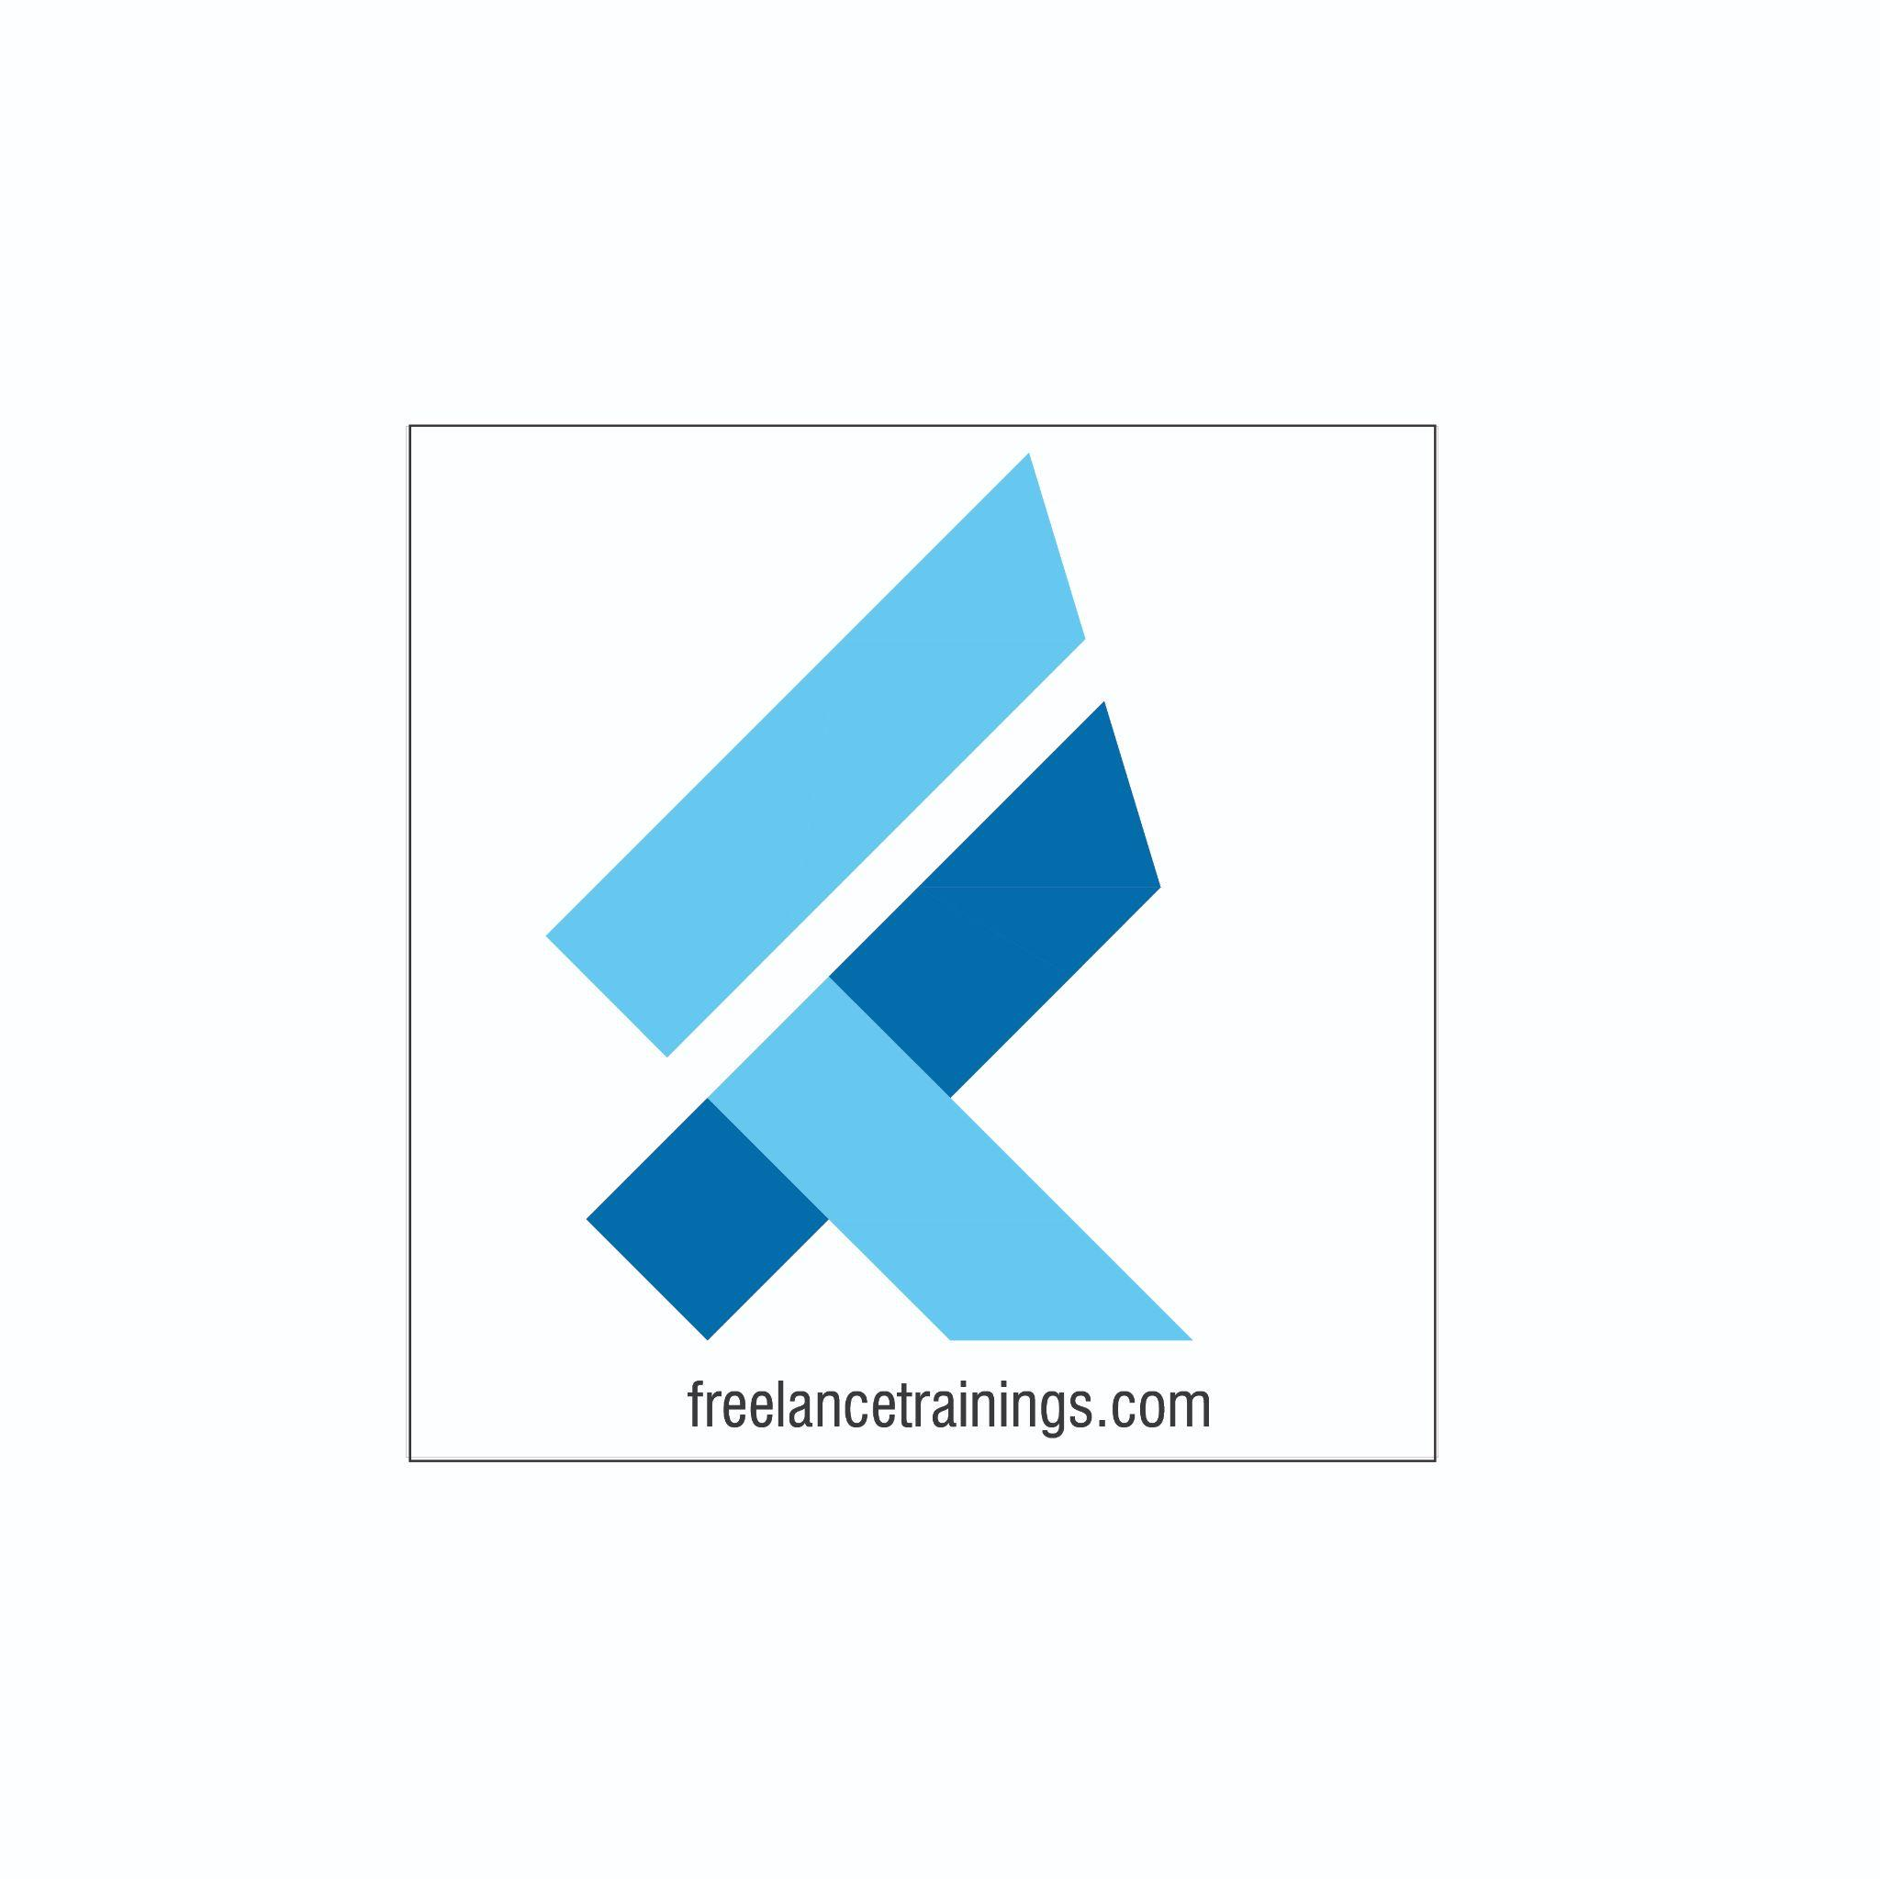
" When a team takes ownership of its problems, the problem gets solved. It is true on the battlefield, it is true in business, and it is true in life”. - Jocco Willink

Ownership & Accountability Workshop
Duration: 1 Day
No of Participants: 25-30 Pax
Timing: 9:30 A.M- 5:30 P.M


Target Audience
- Individual Contributors
- Supervisors
- Team Managers
- Employees of any department

Workshop Objectives

- Understanding Ownership & Accountability
- Benefits of Accountability to the individuals & Organisation
- Being a solution Centric Professional
- Accountability Ladder (Accountable Vs Victim Approach)
- Developing a Growth Mindset
- Understanding the accountability cycle
- RACI Matrix & PDCA Model
- Personal Strength Analysis


Workshop Outline

Sr. No. | Time | Topic
1 | 9:30 – 10:15 AM | What’s In It for Me  - Workshop Intro & Agenda  - Ground Rules  - Icebreaker  - Facilitator Intro  - Participant Intro & Expectations
2 | 10:15 -10:30 AM | Pre-Training Assessment
3 | 10:30 -11:15 AM | Understanding Ownership & Accountability- Part 1  - Meaning & Context  - Performing to Higher performing  - Becoming a Solution Centric professional  - Areas to build Accountability
4 | 11:15- 11:30 AM | First Tea Break
5 | 11:30- 12:00 AM | Understanding Ownership & Accountability- Part 2  - Accountability pathways  - Overcoming Blames & Excuses  - Accountable & Unaccountable Behaviours  - Accountability & Ownership Scenarios
6 | 12:00 -12:30 AM | Importance of Taking Ownership & Accountability  - Accountability Ladder (Accountable Vs Victim)  - Importance of Ownership
7 | 12:30 -1:30 PM | Opportunities for exercising ownership & accountability  - Mindset is Everything  - Fixed Vs Growth Mindset  - See IT to DO IT Model  - Strategies to building Ownership & Accountability
8 | 1:30 - 2:00 PM | Lunch Break
9 | 2:00 - 2:15 PM | Energiser
10 | 2:15 - 3:00 PM | Key Stages of Accountability Cycle  - 5 Stage accountability cycle  - Set Goals  - Develop Action Plans  - Conduct review meeting  - Appraise performance
10 | 3:00 - 3:45 PM | Learn lessons of Unsuccessful Outcome and develop a plan to overcome it  - RACI Matrix (Responsible, Accountable, Consulted & Informed)  - Steps to create RACI Matrix  - PDCA Cycle (Plan, DO Check & Act)
11 | 3:45 - 4:00 PM | Second Tea Break
12 | 4:00 - 4:30 PM | Personal Strength Analysis  - SWOT Analysis understanding  - Conducting personal SWOT Analysis
13 | 4:30 – 4:45 PM | Post-Training Assessment
14 | 4:45 – 5:30 PM | Closing  - Feedback forms  - Q& A (If any)  - Closing Video (If any)  - Group Photo

*This Workshop outline is based on the industry best practices and will be customised after discussion with the client. *

