

Collaboration Skills Workshop
"Great things in business are never done by one person, they are done by a team of people" -Steve Jobs

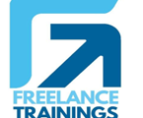

Collaboration Skills Workshop
Duration: 1 Day
No of Participants: 25-30 Pax
Timing: 9:30 A.M- 5:30 P.M

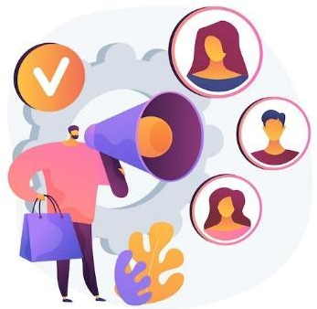
Target Audience
- Individual Contributors
- Supervisors
- Early Team Managers
- Employees of any department
- Cross Functional Teams

Workshop Objectives

- Understanding collaboration skills
- Elements of collaboration skills
- Essential collaboration skills
- Building trust in collaboration
- Building virtual collaboration skills
- Barriers to effective collaboration


Workshop Outline

Sr. No. | Time | Topic
1 | 9:30- 10:15 AM | What’s In It for Me  - Workshop Intro & Agenda  - Ground Rules  - Icebreaker  - Facilitator Intro  - Participant Intro & Expectations
2 | 10:15- 10:30 AM | Pre-Training Assessment
3 | 10:30- 11:15 AM | Collaboration Skills  - What is a collaboration  - Types of collaboration  - Impact of Collaboration on Individuals & Teams  - Myths related to conflicts
4 | 11:15 -11:30 AM | First Tea Break
5 | 11:30 -12:15 PM | Elements of Collaboration Skills  - 5 Elements of Collaboration Skills  - Collaboration Vs Teamwork  - How to Make Collaboration Work: 6 Predictable Stages  - Qualities of a collaborator
6 | 12:15 - 01:00 PM | Essential Collaboration Skills  - Emotional Intelligence  - Effective communication and active listening.  - Building empathy
8 | 1:00 – 1:45 PM | Lunch Break
7 | 1:45 – 2:30 PM | Building Trust in Collaboration  - Importance of Trust in Collaboration  - Tips to build trust  - Managing Conflict  - Conflict Management strategies
9 | 2:30 – 3:30 PM | Building Virtual Collaboration  - Extra challenges of virtual collaboration  - Virtual collaboration tools ideas and suggestions  - Good virtual communication practices
10 | 3:30 – 4:00 PM | Barriers to Effective collaboration  - Common Barriers in collaboration  - Rewarding Team Collaboration
11 | 4:00 – 4:15 PM | Second Tea Break
13 | 4:15 - 4:30 PM | Recap
14 | 4:30- 4:45 PM | Post Training Assessment
15 | 4:45- 5:30 PM | Closing  - Feedback forms  - Q&A (If any)  - Closing Video (If any)  - Group Photo

*This Workshop outline is based on the industry best practices and will be customised after discussion with the client.

