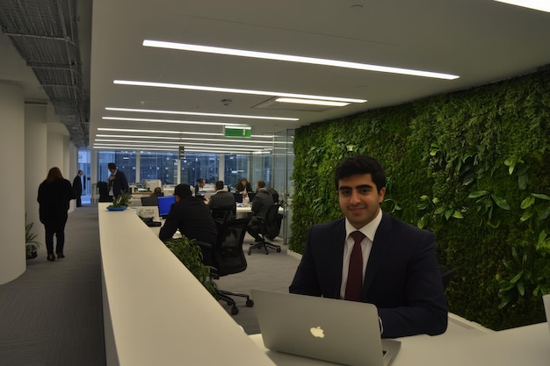
Workshop on Executive Presence

" Executive presence is about the ability to project confidence and
gravitas under pressure."
-Sylvia Ann Hewlett

Executive Presence Workshop
Duration: 1 Day
No of Participants: 25-30 Pax
Timing: 9:30 A.M- 5:30 P.M


Target Audience
- HR Head
- HR Manager
- Manager of Concern Department
- Supervisors of Concern Department

Workshop Objectives
- Understanding Executive Presence
- Story Telling
- Creating a compelling story
- Emotional Intelligence
- Building trust with your people
- The Art of Influence

- Developing Charisma

Workshop Outline

Sr. No. | Time | Topic
1 | 9:30- 9:45 AM | What’s In It for Me  - Workshop Intro & Agenda  - Ground Rules  - Icebreaker  - Facilitator Intro  - Participant Intro & Expectations
2 | 9:45- 10:00 AM | Pre-Training Assessment
3 | 10:00- 10:45 AM | Understanding Executive Presence  - Understand the core elements of executive presence  - The importance of executive presence in leadership  - Real life examples of leaders with strong executive presence  - Assessing personal executive presence
4 | 10:45- 11:00 AM | First Tea Break
5 | 11:00 – 11:45 AM | Understanding story telling  - Understanding story telling  - The impact of story telling in leadership and communication  - Emotional connection through stories  - Stories that inspire and influence
6 | 11:45 – 12:30 PM | Creating a compelling story  - Identifying key messages and themes  - Structuring a compelling narrative  - Using personal and professional anecdotes effectively  - Practice session-Participants craft and share their own stories
7 | 12:30 – 1:15 PM | Emotional Intelligence  - Understanding emotional intelligence  - Techniques for improving self-awareness  - Strategies for managing emotions in challenging situations  - Building empathetic listening skills  - Role play activity-Practicing empathetic communication
8 | 1:15 – 2:00 PM | Lunch Break
9 | 2:00- 2:15 PM | Energiser
10 | 2:15- 3:00 PM | Building trust with your people  - Understanding the biology and psychology of trust  - Building foundation for lasting trust  - Who does not trust enough, will not be trusted  - Learning how to judge trustworthiness-Ability, integrity, benevolence  - Exploring cognitive & affective trust  - Techniques to repair trust
11 | 3:00- 3:45 PM | The Art of Influence  - Developing influence without legitimate power  - Achieving high impact influence with difficult people avoiding the 4 common persuasion mistakes  - Applying cultural intelligence to win hearts and minds  - Psychodynamic influencing techniques  - Igniting team based influencing techniques
12 | 3:45- 4:15 PM | Developing Charisma  - Understanding why attraction towards charismatic people takes place in cultural context  - Learning the secrets of charisma from the world’s top executives  - Applying the psychology of attraction to achieve charismatic excellence  - Enhancing your self-awareness using the five charisma leadership factors  - Harnessing your hidden charisma  - Maximizing type 1 leadership -Introverted charisma
13 | 4:15 - 4:30 PM | Second Tea Break
14 | 4:30 - 4:45 PM | Recap
15 | 4:45 - 5:00 PM | Post Training Assessment
16 | 5:00- 5:30 PM | Closing  - Feedback forms  - Q& A (If any)  - Closing Video (If any)  - Group Photo

*This Workshop outline is based on the industry best practices and will be customised after discussion with the client.*

