

Image Management Workshop
"You too are a brand, whether you know it or not, whether you like it or not" -Marc Ecko

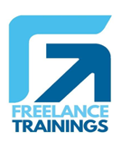

Image Management Workshop
Duration: 1 Day
No of Participants: 25-30 Pax
Timing: 9:30 A.M- 5:30 P.M

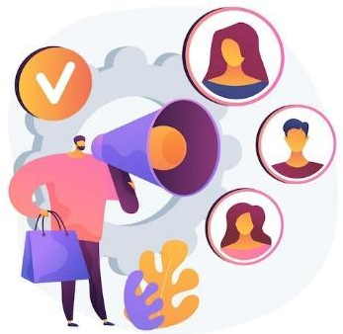
Target Audience
- Individual Contributors
- Supervisors
- Early Team Managers
- Employees of any department
- Sales teams
- Marketing Teams

Workshop Objectives

- Understanding Image Management
- Building an Attitude of Ownership
- Nonverbal Communication
- Body Language
- Looks Matter
- Watch the Odour

Workshop Outline

Sr. No. | Time | Topic
1 | 9:30-10:15 AM | What’s In It for Me  • Workshop Intro & Agenda  • Ground Rules  • Icebreaker  • Facilitator Intro  • Participant Intro & Expectations
2 | 10:15- 10:30 AM | Pre-Training Assessment
3 | 10:30- 11:15 AM | Understanding Image Management  • What is Image management  • Components of Image Management  • Benefits of Image Management to Individuals & Organisations
4 | 11:15 -11:30 AM | First Tea Break
5 | 11:30 - 12:30 PM | Building an Attitude of Ownership  • Understanding Ownership  • Developing a Proactive Approach-Circle of Control  • Building a solution Centric  • Walking the Extra Mile- How to Avoid Blame Game
6 | 12:30 - 1:15 PM | Nonverbal Communication  • Mehrabian Model- (Visual, Vocal & Verbal)  • Components of Visual  • Body Language  • Attire  • Hygiene & Grooming
7 | 1:15 - 2:00 PM | Lunch Break
8 | 2:00 - 2:15 PM | Energizer
9 | 2:15 - 3:15 PM | Body Language (As per Indian Corporate Standard)  • Introduction  • Greetings  • Handshake  • Business Card Etiquette  • Eye Contact  • Personal Space
10 | 3:15 - 4:00 PM | Looks Matter  • Formal Dressing Males & Females  • Casual Dressing  • Accessories for Males & Females  • Belts & Footwear  • Some commonly observed rules
11 | 4:00- 4:15 PM | Second Tea Break
12 | 4:15- 4:45 PM | Watch the Odour  • Knowing the body Odours  • Bad Breath  • Doe Vs. Perfume  • Some commonly observed rules
13 | 4:45 - 5:00 PM | Post Training Assessment
14 | 5:00 -5:30 PM | Closing  • Feedback forms  • Q& A (If any)  • Closing Video (If any)  • Group Photo

*This Workshop outline is based on the industry best practices and will be customised after discussion with the client.

