

Customer Service Workshop
“If you don’t take care of your customer, your competitor will.”
– Bob Hooey

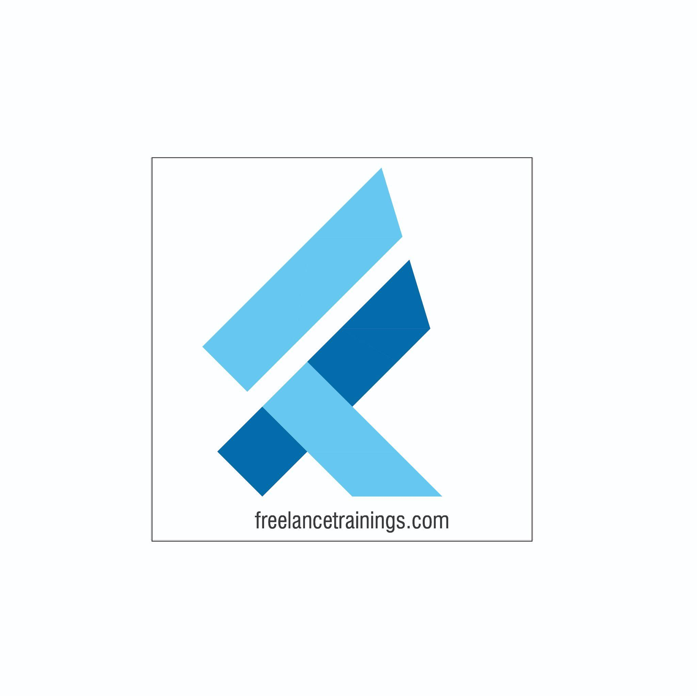

Customer Service Workshop
Duration: 1Day
No of Participants: 25-30 Pax
Timing: 9:30 A.M- 5:45 P.M


Target Audience
- Individual Contributors
- Early Managers
- Supervisors
- Employees of any department

Workshop Objectives
- Customer Service Essentials
- Building an attitude of Ownership & Accountability
- Moment of Truth
- Understanding Customer Needs
- Dealing with an Irate Customer
- Customer Service Professionals


Workshop Outline

Sr. No. | Time | Topic
1 | 9:30-10:15 AM | What’s In It for Me Day  - Workshop Intro & Agenda  - Ground Rules  - Icebreaker  - Facilitator Intro  - Participant Intro & Expectations
2 | 10:15- 10:30 AM | Pre-Training Assessment
3 | 10:30- 11:15 AM | Customer Service Essentials  - What do People Remember and Why.  - What is Customer service  - Importance in Customer Service- Self  - Benefits of great customer service to Organisation
4 | 11:15 – 11:30 AM | First Tea Break
5 | 11:30 – 12:30 PM | Building an attitude of Ownership & Accountability  - Understanding Ownership  - Developing a Proactive Approach-Circle of Control  - Building a solution Centric  - Avoid Blame Game- Walking the Extra Mile
6 | 12:30 – 1:15 PM | Moment of Truth  - Understanding Moment of Truth  - Moment of Misery Vs Moment of Magic  - Exploring the customer delight moments  - Building The Tragics into Magics
7 | 1:15 – 2:00 PM | Lunch Break
8 | 2:00 - 2:15 PM | Energiser
9 | 2:15- 3:00 PM | Understanding Customer Needs  - Creating a safe and respectful work environment  - Active Listening  - Asking Questions (Open Ended Vs Close ended)  - Clarifying doubts  - Reconfirm the understanding
10 | 3:00- 3:45 PM | Dealing with an Irate Customer  - Help him empty the cup.  - Providing solution to the customer  - Closing the interactive with a reassurance and positive words.  - Next Steps to be adhered
11 | 3:45 - 4:00 PM | Second Tea Break
12 | 4:00 - 4:45 PM | Art of Saying No to the Customer  - How to say No to the customer.  - Techniques to say no  - Service recovery Paradox  - Being Empathetic to Customer
13 | 4:45- 5:00 PM | Recap
14 | 5:00- 5:15 AM | Pre-Training Assessment
15 | 5:15 - 5:45 PM | Conclusion/ Closing  - Summary of key points  - Feedback forms  - Q&A session  - Closing Video (If any)  - Group Photo

*This Workshop outline is based on the industry best practices and will be customised after discussion with the client. *

