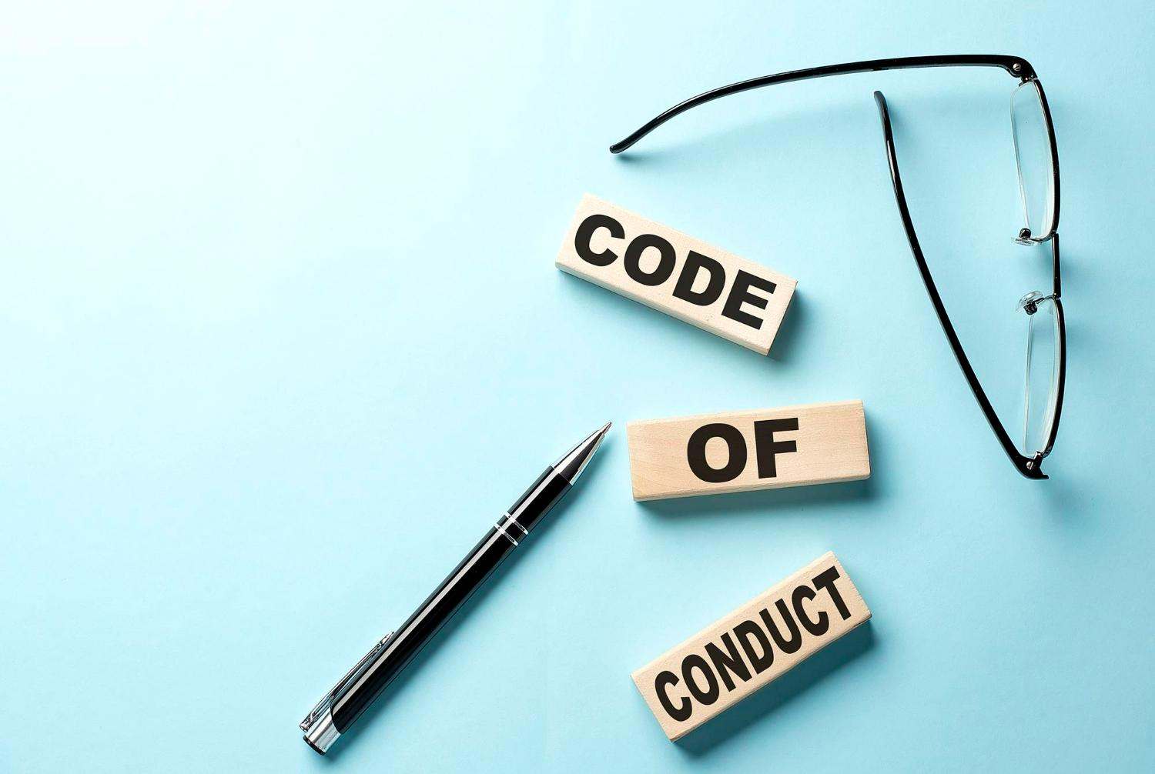

Code of Conduct Training Workshop
“Laws control the lesser man... Right conduct controls the greater one.”
–Mark Twain
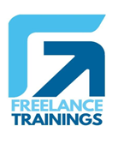

Code of Conduct Workshop
Duration: 3 Hours
No of Participants: 25-30 Pax
Timing: 9:30 A.M- 12:30 P.M


Target Audience
- Individual Contributors
- Supervisors
- Early Team Managers
- New Joiners
- Employees of Any department


Workshop Objectives
- Introduction and Importance of Code of Conduct
- Understanding the Code of Conduct
- Key Elements of the Code of Conduct
- Applying the Code of Conduct
- Reporting Violations and Consequences
- Q&A Session
- Conclusion and Commitment

Workshop Outline

Sr. No. | Time | Topic
1 | 9:30- 09:45AM | Introduction and Importance of Code of Conduct  - Welcome and Introduction to the Workshop  - Briefly explain what a Code of Conduct is  - Emphasize the importance of ethical behavior and a positive work environment
2 | 9:45- 10:15 AM | Understanding the Code of Conduct  - Define a Code of Conduct  - Explain its purpose: guiding behavior, promoting ethics, and maintaining a positive workplace  - Discuss how it aligns with the company's values and mission
3 | 10:15- 11:00 AM | Key Elements of the Code of Conduct  - Ethical Standards and Values  - Define ethics and values in the workplace context  - Provide examples of common ethical dilemmas  - Discuss the company's core values and how they relate to the Code of Conduct  - Respectful and Inclusive Behavior  - Explain the importance of treating all individuals with respect and dignity  - Discuss the company's stance on diversity and inclusion  - Provide scenarios to Illustrate Respectful and Inclusive Behavior  - Conflicts of Interest  - Define conflicts of interest and give examples  - Explain how to identify and address conflicts of interest  - Emphasize the importance of transparency and disclosure
4 | 11:00- 11:15 AM | Break
5 | 11:15- 12:00 PM | Applying the Code of Conduct  - Professional Communication  - Discuss the significance of effective communication  - Provide guidelines for appropriate communication within the company  - Highlight the potential consequences of inappropriate communication  - Workplace Behavior and Attire  - Explain the expectations for professional behavior and attire  - Discuss how personal behavior can impact the workplace environment  - Provide examples of unacceptable behavior and attire  - Use of Company Resources  - Discuss responsible use of company resources, including equipment and facilities  - Address guidelines for data privacy and cybersecurity  - Highlight potential risks associated with misuse of resources
6 | 12:00 -12:20 PM | Reporting Violations and Consequences  - Explain the process for reporting violations of the Code of Conduct  - Discuss protections for whistleblowers  - Outline potential consequences for violating the Code of Conduct, including disciplinary actions
8 | 12:20 - 12:35 PM | Q&A Session  - Open the floor for questions and scenarios from participants  - Facilitate a discussion around real-life scenarios and how the Code of Conduct would apply
9 | 12:35 – 12:45 PM | Conclusion and Commitment  - Summarize key takeaways from the workshop  - Emphasize participants' role in upholding the Code of Conduct  - Encourage participants to commit to ethical behavior and a positive workplace environment

*This Workshop outline is based on the industry best practices and will be customised after discussion with the client.*

