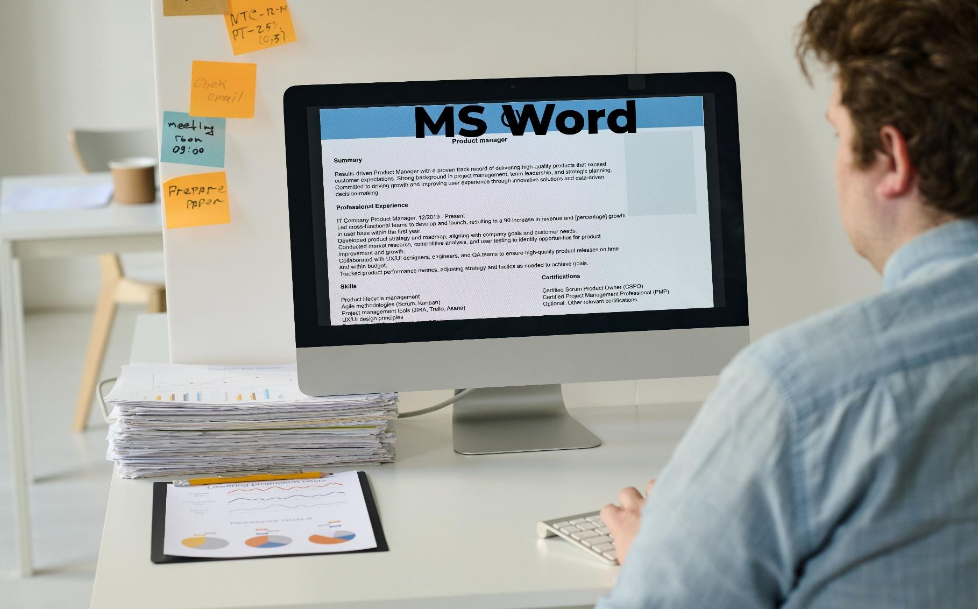

Workshop on Impactful MS Word

"You will never your life until you change something you do daily. The secret of your success is found in your daily routine."
-John.C.Maxwell


MS. Word Workshop
Duration: 1 Day
No of Participants: 25-30 Pax
Timing: 9:30 A.M- 5:30 P.M


Target Audience
- Employees of any department
- Individual Contributors
- Manager of Concern Department
- Supervisors of Concern Department

Workshop Objectives
- The Ribbons
- Basic Document Creation and Editing
- Advanced Text formatting
- Working with Graphics and Objects
- References and Citations
- Collaboration Tools

- Mail Merge

Workshop Outline

Sr. No. | Time | Topic
1 | 9:30- 10:00 AM | What’s In It for Me  - Workshop Intro & Agenda  - Ground Rules  - Icebreaker  - Facilitator Intro  - Participant Intro & Expectations
2 | 10:00- 10:15 AM | Pre-Training Assessment
2 | 10:15 - 10:45 AM | The Ribbons  - File View  - Home  - Insert  - Draw  - Design  - Layout  - References  - Mailings  - Review  - View  - Layout  - Table Design
3 | 10:45- 11:00 AM | First Tea Break
4 | 11:00 – 11:45 AM | Basic document Creation and Editing  - Creating a new document  - Basic Text Formatting (font, size, colour)  - Paragraph Formatting (Alignment, line spacing, indents)  - Saving and Opening documents  - Borders and outlines  - Watermark, Page colour, Page Border
5 | 11:45 – 12:30 PM | Advanced Text Formatting  - Styles and Themes  - Header and Footers  - Page numbers and Page Layout  - Using Templates  - Cover page & Blank Page  - Format Painter
6 | 12:30 – 1:15 PM | Working with Graphics and Objects  - Inserting and Formatting Images  - Adding Shapes, Smart arts and Icons  - Inserting a Table  - Inserting Pictures and Icons  - Smart art  - Text Wrapping and Positioning
7 | 1:15 – 2:00 PM | Lunch Break
8 | 2:00- 2:15 PM | Energiser
9 | 2:15- 3:00 PM | References and Review  - Adding footnotes and Endnotes  - Creating a Table of Contents  - Managing Bibliographies and Citations  - Translate  - Review the document  - Zoom  - Print Layout  - Outline & Draft  - One Pager Vs Multiple pages  - New Window, Split and Arrange All
10 | 3:00- 3:45 PM | Working with Charts  - Inserting a chart  - Formatting a chart  - Chart Types  - Editing data in charts
11 | 3:45- 4:15 PM | Mail Merge  - Setting up a mail merge  - Creating Labels and Envelopes  - Using mail merge with Excel data
12 | 4:15 - 4:30 PM | Second Tea Break
13 | 4:30 - 4:45 PM | Recap
14 | 4:45 - 5:00 PM | Post Training Assessment
15 | 5:00- 5:30 PM | Closing  - Feedback forms  - Q& A (If any)  - Closing Video (If any)  - Group Photo

*This Workshop outline is based on the industry best practices and will be customised after discussion with the client.*

