

First Time Manager Workshop
" A manager is not a person who can do the work better than his men; he is a person who can get his men to do the work better than he can.” – Frederick W. Smith

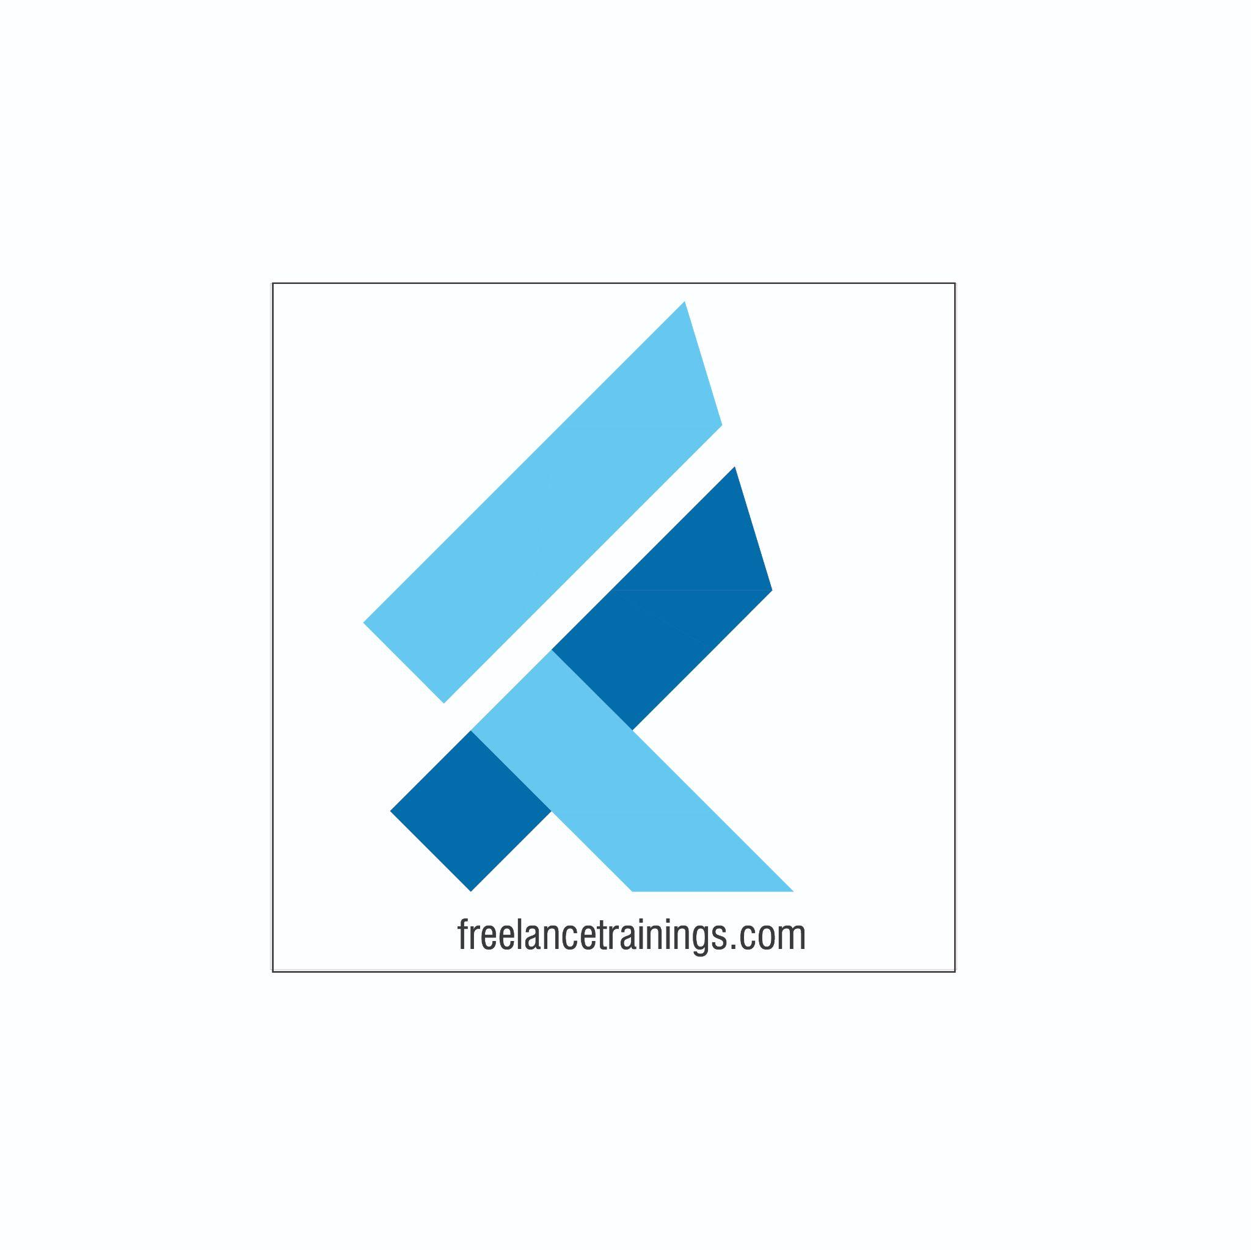

First Time Manager Workshop
Duration: 2 Days
No of Participants: 25-30 Pax
Timing: 9:30 A.M- 5:30 P.M


Target Audience
- First time Managers
- Early Team Managers
- Supervisors
- Individual Contributors to be promoted as Managers

Workshop Objectives

- Understanding Managerial Effectiveness
- Attitude being an effective manager
- Qualities of an Effective Manager
- Setting SMART Goals
- Impactful Team Communication
- Building Dream Teams
- Nurturing Teams- Coaching
- Delegation
- Motivating & Appreciating the Team
- Giving Constructive Feedback

- Time Management- Leveraging Time by Prioritizing

Workshop Outline

Day 1
Sr. No. | Time | Topic
1 | 9:30-10:15 AM | What’s In It for Me  • Workshop Intro & Agenda  • Ground Rules  • Icebreaker  • Facilitator Intro  • Participant Intro & Expectations
2 | 10:15- 10:30 AM | Pre-Training Assessment
3 | 10:30- 11:15 AM | Understanding Managerial Effectiveness  • Understanding Managerial Effectiveness  • Why First Time Manager  • Benefits of a Great Manager- Self  • Benefits of a Great Manager to Organisation  • Challenges Faced by a Manager  • Managerial Ladder
4 | 11:15 – 11:30 AM | First Tea Break
5 | 11:30 – 12:30 PM | Qualities of being an Effective manager- 7C’s  • Competence  • Credibility- Ownership  • Care & Connect-Team  • Communication  • Courage & Commitment  • Credit  • Check
6 | 12:30 – 1:15 PM | Setting SMART Goals  • Competence  • Credibility- Ownership  • Care & Connect-Team  • Communication  • Commitment & Courage  • Credit
7 | 1:15 – 2:00 PM | Lunch Break
8 | 2:00 - 2:15 PM | Energiser
9 | 2:15- 3:00 PM | Making Communication Fool proof  • Applying LADR Model  • Listening Actively  • Asking Questions  • Doubts Clarify  • Reconfirm
10 | 3:00- 3:45 PM | Team Communication  • Modes of Communication (Passive, Aggressive & Assertive)  • Understand Assertive communication  • Following an Assertive communication style  • Empathising with the team members
11 | 3:45 - 4:00 PM | Second Tea Break
12 | 4:00 - 4:45 PM | Delegation-Building Equal Shoulders  • Understanding Delegation  • Why Manager’s Don’t Delegate  • RELAY Model for Effective Delegation  • Tips for Effective Delegation
13 | 4:45- 5:00 PM | Recap of Day 1
14 | 5:00 - 5:30 PM | Closing  • Q& A  • Closing Video  • Homework for day 2 (Optional)
Day 2
Sr. No. | Time | Topic
1 | 9:30-10:00 AM | What’s In It for Me  • Recap of Day 1-Activity  • Agenda
2 | 10:00- 11:00 AM | Building Dream Teams  • Understanding Teams  • Team Building Stages -Tuckman model  • Norming to Adjourning  - Challenges in building Dream Teams  - Building Trust in your team
3 | 11:00 -11:15 AM | First Tea Break
4 | 11:15 - 12:15 PM | Motivating & Appreciating the Team  • Why appreciate  • Appreciation Model  • Specific & Timely Appreciation  • Genuinely appreciate  • How the teams get Motivated  • Top Motivators and Detractors for the team
5 | 12:15 - 1:00 PM | Giving Constructive Feedback  • Understanding constructive Feedback  • What to give feedback on? (Specific Vs Concise)  • When to give feedback? (Time)  • How to give feedback effectively? (Task Vs Behaviour)  • Feedback tools.
6 | 1:00 - 1:45 PM | Lunch Break
7 | 1:45 - 2:00 PM | Energiser
8 | 2:00 – 3:00 PM | Developing your team -Coaching.  • Coaching- a tool for Team development  • Do’s and Don’ts of Coaching  • GROW Model of coaching  • Essentials of Coaching – (Asking Questions & Active listening)
9 | 3:00 – 4:00 PM | Time Management- Leveraging Time by Prioritizing  • Time Management or self-Management  • Prioritising the Tasks  • Prioritising Tool-Urgent Important Matrix  • Organising the Day- Maintaining Daily diary  • How to maintain your Diary or Organizer?
10 | 4:00 - 4:15 PM | Second Tea Break
11 | 4: 15 - 4:30 PM | Recap Day 1 & 2
12 | 4:30 - 4:45 PM | Post Training Assessment
13 | 4:45 -5:30 PM | Closing  • Feedback forms  • Q& A (If any)  • Closing Video (If any)  • Group Photo

*This Workshop outline is based on the industry best practices and will be customised after discussion with the client. *

